A lignin-derived sulphated carbon for acid catalyzed transformations of bio-derived sugars
Churchil A. Antonyraj,* Ajit Haridas
Environmental Technology Division,
National Institute for Interdisciplinary Science and Technology,
Council of Scientific and Industrial Research,
Thiruvananthapuram PIN: 695019
*Email: churchilangel@gmail.com

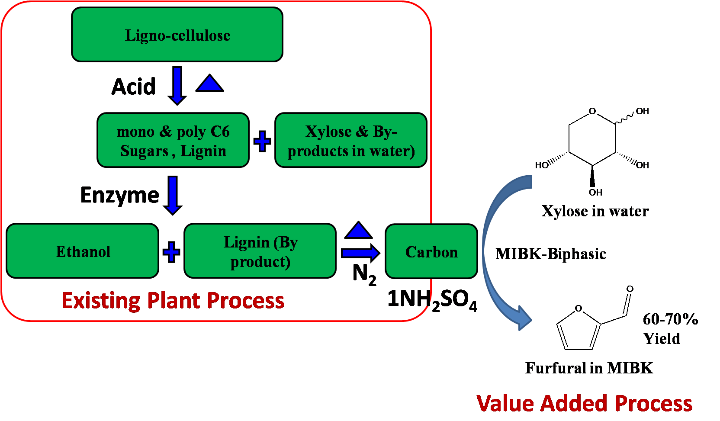
Abstract
Bio-ethanol plant derived crude lignin was utilized in the synthesis of carbon catalysts for the conversion of xylose in acid pretreatment liquid (APL, another by-product of bio-ethanol plant) into furfural. Also, xylose dehydration to furfural by carbon catalysts carried out in water-MIBK biphasic system showed a maximum yield of 60% furfural. In addition, a carbon catalyst modified with 1N H₂SO₄ was found to be highly active as concentrated acids reported earlier in the open literature. Only a small part of the total crude lignin from the bio-ethanol plant was utilized in this manner. Further research is necessary on the valorization of remaining crude lignin waste.

