A lignin-derived sulphated carbon for acid catalyzed transformations of bio-derived sugars
Churchil A. Antonyraj,* Ajit Haridas
Environmental Technology Division,
National Institute for Interdisciplinary Science and Technology,
Council of Scientific and Industrial Research,
Thiruvananthapuram PIN: 695019
*Email: churchilangel@gmail.com

Abstract
Bio-ethanol plant derived crude lignin was utilized in the synthesis of carbon catalysts for the conversion of xylose in acid pretreatment liquid (APL, another by-product of bio-ethanol plant) into furfural. Also, xylose dehydration to furfural by carbon catalysts carried out in water-MIBK biphasic system showed a maximum yield of 60% furfural. In addition, a carbon catalyst modified with 1N H₂SO₄ was found to be highly active as concentrated acids reported earlier in the open literature. Only a small part of the total crude lignin from the bio-ethanol plant was utilized in this manner. Further research is necessary on the valorization of remaining crude lignin waste.
Keywords: Lignin, 5-Hydroxymethylfurfural (HMF), 5-Ethoxymethylfurfural (EMF), Xylose, Furfural.

1. Introduction
In recent years of exclusive research, biomass was found to be an excellent renewable resource for fuels and chemicals. Eco-friendly nature and cost-effectiveness makes biomass an attractive commodity. The emerging trend of re-utilizing agricultural waste/industrial waste becomes a prime focus for many research groups worldwide. Waste reduction/utilization and by-products value addition in industrial/agricultural sector replaces the need for utilizing biomass as source for chemicals and fuels. Lignocellulose from various agricultural wastes being an abundant and renewable resource has been used for bio-ethanol production. In the consecutive steps of ethanol production, C5 carbohydrate(xylose) rich acid pretreatment liquid (APL), as well as crude lignin are obtained as waste (Scheme S1, Supplementary Information) [3,4]. Herein, we propose to convert the APL waste by-product into furfural, a valuable and renewable chemical feedstock by heterogenous catalysis, using crude lignin derived carbon catalysts. Thus, furfural, a valuable chemical used in the production of solvents, fuel additives, resins and adhesives [5-8] can be made available in lower cost. Moreover, heterogeneous catalysis, a cheaper and environmental friendly chemical reaction process had been adapted for furfural production from xylose, thus making it industrially feasible. Multiple metal oxides and metal oxide composite-based heterogeneous acid catalysts were reported for the conversion of xylose (from different biomass precursors) to furfural in different solvent systems [9-12]. However, oxide catalysts show leaching while reusing the catalyst, and they are not successful for the process development [11,13].
In the present work, we have been successful in developing a reusable carbon catalyst from crude lignin, yet another by-product from the same bioethanol plant, for the production of furfural. More precisely, our objective is to produce furfural from APL as valorization using a stable and reusable heterogeneous catalyst. The substrate APL is completely different from other biomass precursors, constituting ~ 6 wt% C5 carbohydrate (xylose) along with some C6 carbohydrates and soluble polymer/humins at pH of 3.5 - 4.5. Hence, it is important to conduct the heterogenous catalytic process in an acidic aqueous medium. Our second objective is to reutilize crude lignin from a bio-ethanol plant for the synthesis of carbon-based acid catalysts (Scheme S1). Such carbon-based catalysts are stable under acidic reaction conditions, and some of them were proven to be successful towards dehydration/hydrolysis reactions [14-18]. Being a by-product of the same process, the carbon-based catalyst should be considered cheaper. To the best of our knowledge, only one report is available on the dehydration of such pretreatment liquids but using homogeneous acid catalysts with 60% yield [19]. Herein, a similar yield was achieved using a cheaper heterogeneous catalyst in an economically feasible reaction process with good prospect of becoming a future industrial technology.
Carbon-based catalysts obtained from waste biomass was reported to have low surface area, whereas acid treatment enhances the surface acid density compared to commercial activated carbon or charcoal [20-22]. Herein, we have investigated the influence of varied acid concentration on the functionalization of catalytic materials and their derived textural and catalytic properties.
2. Materials and Methods
Xylose (>99%), Hydroxymethylfurfural (HMF) (>99%) and 5-Ethoxymethylfurfural (97%) were purchased from Sigma Aldrich Chemicals, Germany. Fructose (98%), Furfural (98%), Methylisobutylketone (MIBK), Sulphuric acid and Potassium hydroxide were purchased from SD Fine Chemicals, India.
2.1 Analytical Methods
Powder X-ray diffraction analyses (PXRD) were conducted using XEUSS SAXS/WAXS system and a Genix microsource (Xenocs) operated at 50 kV and 0.6 mA. The Cu Kα radiation (λ= 1.54 Å) was collimated with FOX2D mirror and two pairs of scatter less slits (Xenocs). The 2D-patterns were recorded on a Mar345 image plate and processed using Fit2D software. All the measurements were made in the transmission mode. The data were processed using the Philips X'Pert (version 2.2e) software. Scanning electron microscopy (SEM) measurements were performed using a JEOL Series JSM-5600LV microscope equipped with EDX (Oxford Instruments). The samples were sputter-coated with gold before imaging. Images were obtained at an accelerating voltage of 20 kV. Thermo gravimetric (TG) analyses were carried out using a PerkinElmer Pyris Diamond TG/DTA, in flowing nitrogen (50 ml min⁻¹) and at a heating rate of 15 °C min⁻¹. Specific surface areas (SSA, m² g⁻¹) and pore size distributions of the porous solid samples were measured by nitrogen adsorption at −196 °C using a sorptometer (Micromeritics, Tri Star - GEMINI). The samples were degassed at 200 °C for 4 h prior to the measurements and the data were analyzed using built-in software. The total acidity of the carbon-based catalysts was estimated using acid-base titration methods reported in the literature [23]; 50 mg of catalyst was added to 0.1N NaOH solution and stirred for 10 min. This was then diluted with another 5 ml of water to which 2 drops of phenolphthalein indicator was added and titrated against 0.1 N HCl solutions.
2.2 Lignin Estimation (Klason Method)
Oven dried (103 °C ±2) sample (1 g) was treated with 98% H₂SO₄ (9.4 ml) at 30 °C for 1 h. The solution was diluted to a total volume of 262 ml using distilled water. This was autoclaved at 121 °C for 1 h, filtered and dried in oven at (103 °C ±2) and weighed; such filter cake was calcined in a furnace at 550 °C for 5h in air. Lignin content was determined by the weight loss during calcination.
2.3 Catalysts preparation
Calculated weight of crude lignin was placed in a crucible and calcined using Nabertherm –B180 horizontal flow furnace. Calcination was conducted in N₂ flow (1L/min) at 450 °C for 1 h in order to obtain lignin-derived carbon (LC). Sulphate functionality modification was introduced by taking 3 g of crushed carbon (LC) in a 250 ml round bottom flask to which 100 ml sulphuric acid solution with different concentration (36N, 6N, 1N and 0.5N) was added and then placed in an oil bath at 60 °C for 18 h with stirring. The obtained solid samples were filtered, washed with water until neutral pH and dried in an oven at 100 °C overnight. The solid carbon-based thus modified catalysts were named LC-36S, LC-6S, LC-1S and LC-0.5S, respectively. These different modified carbon catalysts were used in separate reactions to assess their performance.

2.4 Catalytic Reactions
2.4.1 Xylose dehydration
In a 100 ml Parr reactor, 28 ml of MIBK and given amount of catalyst were added to 12 ml of 6.67 wt% xylose standard solution. Reactions were carried out using unmodified and modified carbon catalysts separately. The reactor was flushed with N₂ and pressurized with N₂ at 20 bar. Reaction was conducted at 175 °C (unless mentioned) at 700 rpm for 3 h. After the reaction, both aqueous and organic layers were collected and analyzed for xylose conversion and furfural yield with HPLC (Shimadzu – LC-10AD with RID 6A RI detector) using 0.008N H₂SO₄ buffer and Bio-Rad Aminex HPX-87H (300 × 7.8 mm) column at 50 °C. The obtained results were analyzed using Autochro-3000 software. Xylose conversion and furfural yield were calculated using external standard cures constructed using the authentic samples by the following equations:
Xylose conversion = (moles of xylose reacted/moles of starting xylose) * 100% (1)

Furfural yield = (moles of furfural produced/moles of starting xylose) * 100% (2)

Turn over number (TON) was calculated by the following equation:
TON = moles of furfural produced/moles of active site (H⁺) (3)
2.4.2 Fructose to EMF
The 100 ml Parr reactor was loaded with 2 wt% fructose in ethanol solution along with 200 mg of catalyst. Reactor was flushed with N₂ and pressurized with 20 bar N₂ (operating pressure). Reaction was conducted at 150 °C for 3 h at 700 rpm. After the reaction, fructose conversion and HMF yield was calculated and analyzed with HPLC (Shimadzu – LC-10AD with RID 6A RI detector) using 0.008N H₂SO₄ buffer and Bio-Rad Aminex HPX-87H (300 × 7.8 mm) column at 50 °C. The results were analyzed using Autochro-3000 software. EMF yield was analyzed using DIONEX HPLC (Ultimate 3000) and a reversed-phase C18 column (150 × 4.6 mm) at 30 °C. The optimized mobile phase consisted of acetonitrile and 0.1 wt % acetic acid aqueous solution with a volume ratio at 15:85. The flow rate was set at 1.0 mL/min and samples were detected at a wavelength of 280 nm. GC-MS analysis was performed for all reactions to detect and quantify levulinic acid ethylester (LEAA) and the yields were calculated using EMF standard solutions by injecting 0.1 μL of the sample into Shimadzu GC-MS-QP2010 Ultra with a Rxi-5ms column(30 m length).
3. Results and Discussion
Crude lignin from a bio-ethanol plant contains 55-60 wt% of lignin and the rest constitutes of other residual biomass as calculated by the Klason method. This composition may differ depending on the kind of ligno-cellulosic source used for ethanol production. On the calcination of crude lignin performed at 450 °C, carbon catalysts (LC) with ~ 40 - 45% yield was obtained. Acidic nature was introduced to LC after its treatment with different concentrations of sulphuric acid, namely: 0.5N, 1N, 6N and 36N.
Powder X-ray diffraction (PXRD) analyses of these carbon catalysts are given in Fig. S1 and all LC catalytic materials show unusual residual reflections at 2θ values of 25.4°, 26.5° and 31.3°, which might be due to partially decomposed biomass precursors [24]. On treatment with different acid concentrations, LC shows reduction in the reflections of 25.4° and 31.3°, whereas the 26.5° reflection was unaffected.
Scanning electron microscopy (SEM) (Fig. 1) reveals that fibrous morphology of the cotton stalk was partially retained even after bio-ethanol production followed by carbonization. LC also contains regular surface pores which might be formed due to the gas evolved during calcination. LC shows surface roughness on sulphate treatment, however, noticeable variation is not observed on different concentration of H₂SO₄ treatments. SEM-EDX analysis confirms the sulphur loading over the surface of these carbon catalysts (Fig. 1); it is difficult to quantify the extent of functionalization since it is a surface analysis technique.
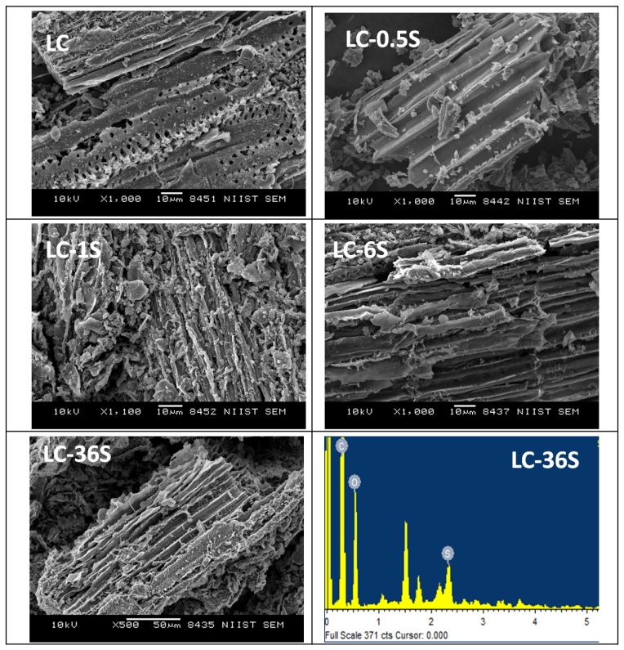
Figure 1. SEM analysis of synthesized carbon catalysts and SEM-EDX analysis of LC-36S.
To study the degree of sulphonation, the total acidity of LC was quantified by acid- base titration (Table 1). Total acidity of the catalyst increases with increasing H₂SO₄ concentration. For example, acid density increases from 0.55 MeqH⁺/g to 1.73 MeqH⁺/g for the 0.5N H₂SO₄ and 6N H₂SO₄ but no change thereafter was observed. Our carbon catalyst has a surface area of ~ 25 m²/g, whereas other lignocellulosic biomass- derived carbon materials reported in the literature had surface areas <20 m²/g [25]. This slightly higher surface area might be due to the pretreatments crude lignin had undergone during the bio-ethanol production (unique property of these materials), which can have a positive impact on the catalytic activity. TG-DTA analysis of the samples showed that the thermal stability of the carbon materials slightly increases on acid treatments (Fig. S2).

Table 1 Surface textural properties and catalytic performance of xylose dehydration of sulphated carbon materials.
Sample No: | Catalyst | Acidity (MeqH⁺/g) | BET (m²/g) | BJH Pore volume (cm³/g) | Xylose Conversion (%) | Furfural Yield (%) | TON
1 | LC-36S | 1.73 | 26 | 0.0332 | 94.3 | 58.8 | 9.1
2 | LC-6S | 1.73 | 32 | 0.0337 | 96.2 | 61.9 | 9.5
3 | LC-1S | 0.85 | 37 | 0.0296 | 96.7 | 64.8 | 20.3
4 | LC-0.5S | 0.55 | 38 | 0.0395 | 89.8 | 58.8 | 28.5
5 | LC* | 0.14 | 24 | 0.0296 | 96.9 | 26.8 | 51.0
6 | Nil | - | - | - | 70.7 | 27.5 | -
7 | 1N H₂SO₄(1ml) | - | - | - | 95.0 | 45.2 | -
Conditions: Xylose 6.67 wt% solution 12 ml, MIBK 28 ml, Catalyst 200 mg, Temperature 175°C, Pressure 20 bar, Time 3h. * Formic acid and levlinic acid were observed.
Xylose reactant solution (6.67 wt%) was made by dissolving 8 g of Xylose in 120 ml of water and used as standard in all reactions conducted in a high pressure catalytic reactor under N₂ environment. The obtained catalytic results are given in Table 1. Among the materials screened, LC-36S, LC-6S and LC-1S show similar conversions of xylose, and LC-1S has slightly higher yield of furfural. Xylose dehydration to furfural along with by-product humins/soluble polymer might be the reason for lesser furfural yield [26]. Acid catalyst synthesized with very low sulphuric acid (1N) treatment shows the highest furfural yield of ~ 65%. To our knowledge, this is the first report showing higher yield using carbon treated with low concentration of sulphuric acid [27]. The low concentration of H₂SO₄ has the advantage of easy handling during bulk production compared to the con. H₂SO₄. LC-0.5S and LC-1S show moderate turnover number (TON) of 28 and 20, respectively. Though unmodified LC catalyst shows higher TON of 51, which is not selective towards furfural, by-products, like formic acid and levulinic acid are also formed.
LC-1S was used for further reactions owing to its high furfural yield and specificity. To find out the homogeneous reaction contribution, the reaction was conducted using 1N H₂SO₄ under identical biphasic reaction conditions, like 175 ℃ and 20 bar pressure for 3 h reaction time (Table 1 Sample No 7). This yielded 95% xylose conversion with only 45% furfural yield, 25% lactic acid as degradation product, and humins, according to the HPLC profile given in Fig. S3. Thus, homogeneous reaction conditions are found to be non-selective and lead to degradation products rather than the selective formation of furfural.
In order to find out sulphur leaching from the catalyst during reaction, the reaction was conducted by taking 12 ml of water, 28 ml of MIBK and 200 mg of LC-1S catalyst without the addition of xylose (reaction was conducted at 175 ℃ and 20 bar pressures for 3 h). The water layer was collected and a reaction was conducted using this acid leached water without the addition of catalyst, which showed ∼ 70% xylose conversion with 27.5% furfural yield, which is similar to catalyst free (without catalyst) reaction (Sample No. 6 in Table 1).
Parametric variations were done to study the influence of various important experimental parameters on the yield of furfural (Fig. 2). Temperature has a strong influence on this reaction; as the temperature increases conversion of xylose and yield of furfural increase up to 175 °C but drop thereafter. This might be due to the associated by-products humins/soluble polymers formed in this reaction, which was evidenced by the deep brown color of the product mixture. Pressure variation studies showed that the pressure has very little influence on the reaction. Even though the furfural yield obtained in the present work is slightly lower than the values reported using other heterogeneous catalysts [28-30], availability of a cheaper catalyst and solvent along with environment friendly synthetic methods of the catalyst makes the present catalytic process attractive.
As per the bi-phasic solvent systems, water-tetrahydrofuran and water-n-butanol were tested for the reaction of xylose to furfural along with the addition of NaCl (0.4 equivalent) under optimal reaction conditions. The furfural yield obtained was 21 and 13%, respectively. This shows that water-MIBK appears as the best solvent system under the examined reaction conditions.
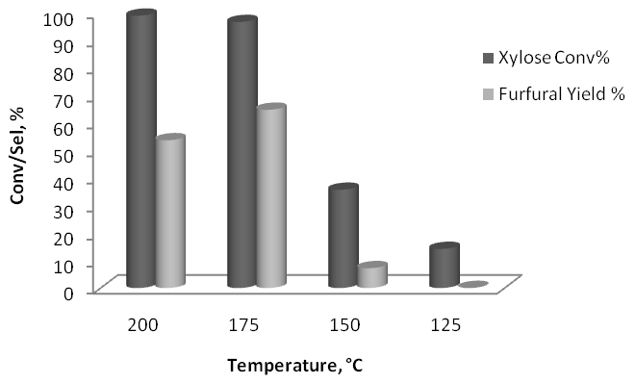 | 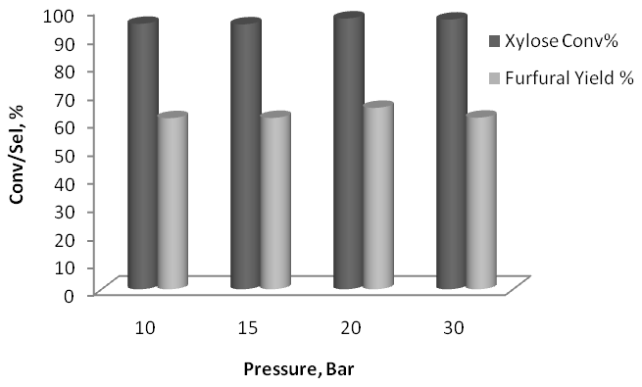
A. Influence of temperature on xylose conversion using the LC-1S catalyst.  # Conditions: Xylose 6.67 wt% solution 12 ml, MIBK 28 ml, Catalyst 200 mg, Pressure 20 bar, Time 3h. | B. Influence of pressure on xylose conversion using the LC-1S catalyst.  # Conditions: Xylose 6.67 wt% solution 12 ml, MIBK 28 ml, Catalyst 200 mg, Temperature 175°C, Time 3h.
Figure 2. Parametric variation studies using the LC-1S catalyst.
The catalytic potential of LC materials was assessed in yet other reactions, namely, the direct conversion of fructose to ethoxymethylfurfural (EMF) in ethanol solvent, where the obtained results are given in Table 2. With increasing acid concentration (LC-0.5S to LC-36S), the EMF yield largely increases from 4.1% to 64.1%, which confirms the linear relationship of EMF formation with the concentration of acid used for catalyst’s modification. This affirms that fructose dehydration reaction requires higher concentration of acidic sites on the catalyst surface than that for xylose dehydration. Furthermore, the LC-0.5S catalyst shows 71.3% fructose conversion with 24.3 and 4.1% HMF and EMF yields respectively. This is the first report which shows the large catalytic activity of carbon materials modified with a low concentration of acid. These results can be compared to recent reports for the synthesis of EMF from fructose using heteropoly acid supported K10, aluminium exchanged K10 clay and MCM-41 supported phosphotungstic acid catalysts [31-33]. Our present study also provides information on the potential reuse of LC catalyst towards the production of EMF from fructose. It was found that after 3 cycles of LC-36S catalyst use, the fructose conversion marginally decreased (from 100 to 98.5%), whereas the EMF yield dropped from 64.1 to 42.5%, while HMF yield increased (from 0 to 15. The reaction conditions used were exactly the same as those reported in Table 2.
Table 2. Fructose dehydration in ethanol over different sulphated carbon catalytic materials.
Sample No: | Catalyst | Fructose Conversion (%) | HMF Yield (%) | LAEE Yield (%) | EMF Yield (%) | Overall Carbon Yield (%)
1 | LC-36S | 100 | 0 | 21.7 | 64.1 | 85.8%
2 | LC-6S | 100 | 9.5 | 10.2 | 58.5 | 78.2%
3 | LC-1S | 93.7 | 26.6 | 2.5 | 39.5 | 74.9%
4 | LC-0.5S | 71.3 | 24.3 | 0 | 4.1 | 57.1%
#Conditions: Fructose 800mg, Ethanol 40 ml, Catalyst 200 mg, Temperature 150 °C, Pressure 20 bar, Time 3h.

For the reuse of catalyst immediately after xylose dehydration reaction, the catalyst was filtered, washed with acetone and dried in an oven at 70 °C. The catalyst was active up to 3 cycles with very small change in the conversion/selectivity but its performance declined thereafter (Fig. 3). The loss in activity of the catalyst during the 4th continuous cycle might be due to the leaching of the acidic sites during reaction. To confirm this hypothesis, the total acidity of the spent catalysts was measured and given in Table S1. The results reported clearly indicate that the decline in activity was due to the loss of acidic sites during reaction. To retain the activity, the catalyst was regenerated by treating it again with 1N sulphuric acid at 80 °C. It should be noted that these carbon materials (LC) are stable under acidic reaction conditions, where no change in the weight of the materials was observed after reaction. Also, PXRD of the used catalyst did not show any change in its bulk structure (Fig. S4). This stable nature of carbon catalysts (LC) makes them more attractive than previously reported oxide-based catalysts.
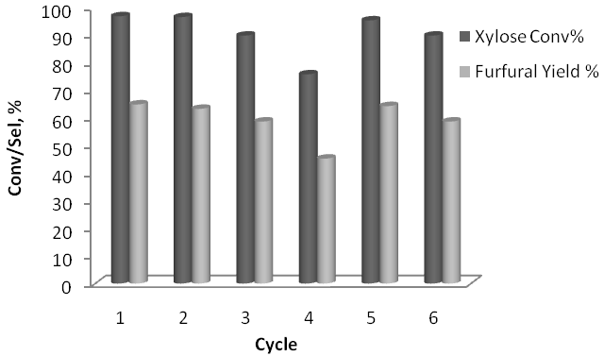
Figure 3. Recyclability of LC-1S catalyst.
* After 4th cycle catalyst was regenerated, # Conditions: Xylose 6.67 wt% solution 12 ml, MIBK 28 ml, Catalyst 200 mg, Temperature 175°C, Pressure 20 bar, Time 3h.

APL obtained from our pilot plant contained only 1.67wt% of xylose, which is almost 4 times lower in concentration than the working standard (6.67wt%), and its composition is given in Figure S5. Freshly obtained APL (pH of 3.5) showed 100% xylose conversion and 60% furfural yield when the reaction was conducted with 200 mg of LC-1S catalyst, 12 ml of APL, 28 ml MIBK at 175 ℃ and 20 bar pressure for 3 h. It is of interest to note that older APL sample (though there was no observable change in the xylose concentration) showed poor furfural yield, which might be due to the formed coloring chemical compounds able to block active sites of the catalyst by strong adsorption. It needs to be mentioned here that the carbohydrates present in APL are not stable due to the low pH value; the color of the APL changes to deep brown/black (even samples stored in refrigerator for longer intervals showed marginal change in the furfural yield).
To study the influence of acidic nature of APL, a control reaction was conducted without catalyst using 12 ml of APL and 28 ml MIBK solvent at 175 ℃ and 20 bar pressure for 3 h. The composition of control reaction is given in Figure S6, where the catalyst free reaction is not selective and leads to several acid products, like lactic acid, acetic acid, levulinic acid and butyric acid. The catalyst on reusability showed only 80% conversion after the 3rd cycle, which might be due to adsorbed polymers from APL liquid, blocking active sites. Scheme 1 shows the proposed process to produce furfural from APL. Both solvent and catalyst are reused during the process and residual carbohydrates and by-products can be used for biogas production.
In an ideal production of bio-ethanol from ligno-cellulosic biomass, 1kg of biomass should give approximately 450g of crude lignin waste and 2.5 L of APL (contains ~ 6wt% of C5 carbohydrates). A material balance calculation shows that 450g of crude lignin waste can produce 180g LC (40% yield). From our studies on xylose, 1 g of catalyst (LC) with 3 times reusability and single regeneration can convert 480ml of APL, thus, 4% of the entire crude lignin waste is considered enough for the complete conversion of APL (from the same process). Since this chemical process does not close completely the material balance, further research is essential for the utilization/valorization of the remaining lignin.
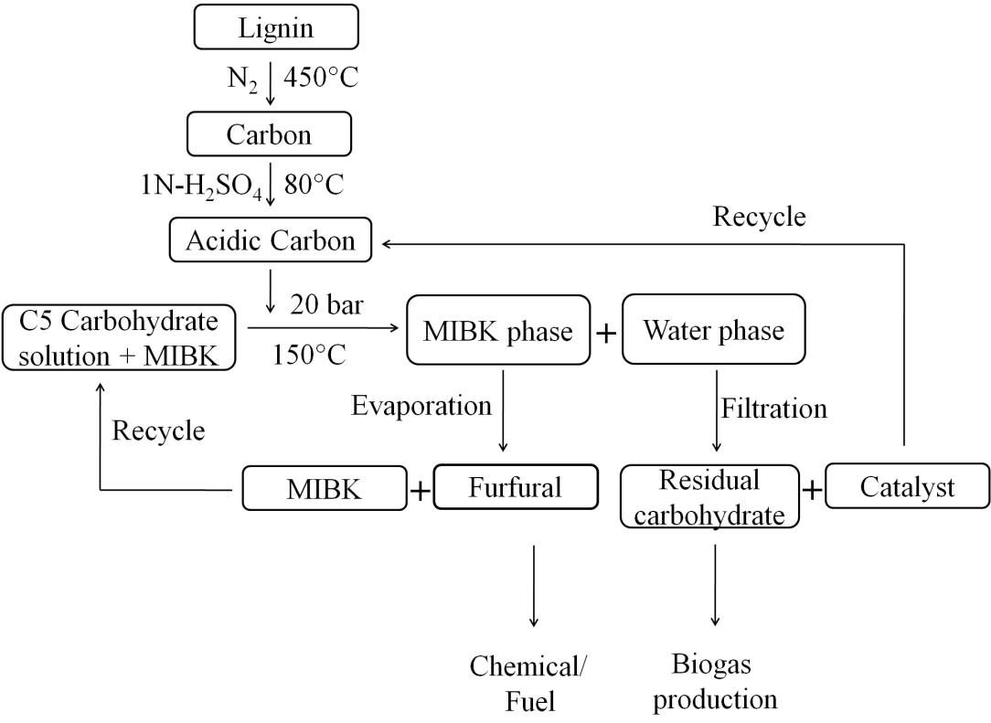
Scheme 1: Proposed processes for the production of furfural.

4. Conclusions
Two waste by-products of a bio-ethanol plant, namely APL and lignin can be used synergistically to produce value-added product furfural. Improved catalytic activity with higher furfural yield from xylose was attained by the acidification of carbon catalyst derived from crude lignin (LC) with 1N H₂SO₄. Extended use of LC in other dehydration reactions, like fructose to EMF, is an added advantage. Reusability up to 4 cycles and thereafter restoration of activity by acidification makes LC a promising catalyst for practical applications. Freshly obtained APL provided 100% xylose conversion with 60% furfural yield. It was estimated that 4% of total crude lignin waste is sufficient for entire APL (from the same process) dehydration. Further research is needed for the utilization/valorization of the remaining lignin. The presently proposed methodology could be adopted for future industrial production of furfural.
Acknowledgements
C.A. Antonyraj thanks the Department of Science and Technology, New Delhi for financial assistance (research project sponsored under DST-SERB for young scientist award - SERB/F/1856/2015-16).
Supplementary Information
Supplementary information is available for TGA analysis of LC materials, PXRD, acidity of used catalytic materials and HPLC profiles of APL before and after reaction.

References
[1] J.N. Chheda, G.W. Huber, J.A. Dumesic, Angew. Chem. Int. Ed. 46 (2007) 7164-7183.
[2] R-J. Van Putten, J.C. Van der Wall, E. de Jong, C.B. Rasrendra, H.J. Heeres, J.G. de Vries, Chem. Rev. 113 (2013) 1499-1597.
[3] P. Binod, R. Sindhu, R.R. Singhania, S. Vikram, L. Devi, S. Nagalakshmi, N. Kurien, R.K. Sukumaran, A. Pandey, Bioresour.Technol. 101 (2010) 4767-4774.
[4] R. Sindhu, E. Gnansounou, P. Binod, A. Pandey, Renew. Ener. 98 (2016) 203-215.
[5] Y. Kar, H. Deveci, Energy Sources 28 (2006) 909-921.
[6] J.J. Bozell, G.R. Petersen, Green Chem. 12 (2010) 539-554.
[7] A. Mamman, J.-M. Lee, Y.-C. Kim, I. Hwang, N-J. Park, Y. Hwang, J.S. Chang, J-S. Hwang, Biofuels Bioprod. Bioref. 2 (2008) 438-454.
[8] P. Dongre, M. Driscoll, T. Amidon, B. Bujanovic, Energies 8 (2015) 7897-7914.
[9] L.X. Zhang, H.B. Yu, P. Wang, Y. Li, Bioresour. Technol. 130 (2016) 110-116.
[10] H.L. Li, A.J. Deng, J.I. Ren, C.Y. Liu, Q. Lu, I.J. Zhong, F. Peng, R.C. Sun, Bioresour. Technol. 158 (2014) 313-320.
[11] H.L. Li, A.J. Deng, J.I. Ren, I.J. Zhong, R.C. Sun, I. Liang, Bioresour. Technol. 176 (2015) 242-248.
[12] E.I. Gurbuz, J.M.R. Gallo, D.M. Alonso, S.G. Wettstein, W.Y. Lim, J.A. Dumesic, Angew. Chem. Int. Ed. 52 (2013) 1270-1274.
[13] P.L. Dhepe, R. Sahu, Green Chem. 12 (2010) 2153-2156.
[14] X. Qi, H. Guo, L. Li, R. L. Smith. Jr., ChemSusChem 5 (2012) 2215-2220.
[15] E. Lam, J. H. Chong, E. Majid, Y. Liu, S. Hrapovic, A.C.W. Leung, J.H.T. Luong, Carbon 50 (2012) 1033-1043.
[16] H. Guo, X. Qi, L. Li, R.L. Smith Jr., Bioresour. Technol. 116 (2012) 355-359.
[17] S. Suganuma, K. Nakajima, M. Kitano, D. Yamaguchi, H. Kato, S. Hayashi, M. Hara, J. Am. Chem. Soc. 30 (2008) 12787-12793.
[18] F. Guo, Z. Fang, T-J. Zhou, Bioresour. Technol. 112 (2012) 313-318.
[19] M.M. Baktash, L. Ahsan, Y. Ni, Sep. Purif. Technol. 149 (2015) 407-412.
[20] K. Nakajima, M. Hara, S. Hayashi, J. Am. Ceram. Soc. 90 (2007) 3725-3734.
[21] W-Y. Lou, Q. Guo, W-J. Chen, M-H. Zong, H. Wu, T. J. Smith, ChemSusChem 5 (2012) 1533-1541.
[22] X. Mo, D.E. Lopez, K. Suwannakarn, Y. Liu, E. Lotero, J.G. Goodwin Jr., C. Lu, J. Catal. 254 (2008) 332-338.
[23] J. Pang, A. Wang, M. Zhenga, T. Zhang, Chem. Commun. 46 (2010) 6935.
[24] Q-Y. Liu, F. Yang, Z-H. Liu, G. Li, J. Ind. Eng. Chem. 26 (2015) 46-54.
[25] J.J. Manya, Environ. Sci. Technol. 46 (2012) 7939-7954.
[26] B. Danon, G. Marcotullio, W. de Jong, Green Chem. 16 (2014) 39–54.
[27] I. Agirrezabal-Telleria, I. Gandarias, P.L. Arias, Catal. Today 234 (2014) 42-58.
[28] L.X. Zhang, H.B. Yu, P. Wang, Y. Li, Bioresour. Technol. 151(2014) 355-360.
[29] I. Zhang, H. Yu, P. Wang, Bioresour. Technol. 136 (2013) 515-521.
[30] Z.P. Xu, W.Z. Li, Z.J. Du, H. Wu, H. Jameel, H.M. Chang, L.I. Ma, Bioresour. Technol. 198 (2015) 764-771.
[31] A. Liu, B. Liu, Y. Wang, R. Ren, Z. Zhang, Fuel 117 (2014) 68-73.
[32] A. Liu, Z. Zhang, Z. Fang, B. Liu, K. Huang, J. Ind. Eng. Chem. 20 (2014) 1977-1984.
[33] B. Liu, Z. Gou, A. Liu, Z. Zhang, J. Ind. Eng. Chem. 21 (2015) 338-339.

List of Figures
Figure 1 | SEM analysis of synthesized carbon materials and SEM-EDX analysis of LC-36S
Figure 2 | Parametric variation studies using the LC-1S catalyst. (A). Influence of temperature on xylose conversion using the LC-1S catalyst (Conditions: Xylose 6.67 wt% solution 12 ml, MIBK 28 ml, Catalyst 200 mg, Pressure 20 bar, Time 3h) and (B) Influence of pressure on xylose conversion using the LC-1S catalyst (Conditions: Xylose 6.67 wt% solution 12 ml, MIBK 28 ml, Catalyst 200 mg, Temperature 175°C, Time 3h).
Figure 3 | Recyclability of the LC-1S catalyst.  * After 4th cycle catalyst was regenerated  # Conditions: Xylose 6.67 wt% solution 12 ml, MIBK 28 ml, Catalyst 200 mg, Temperature 175°C, Pressure 20 bar, Time 3h

