CHAPTER 1

AN INTRODUCTION TO THE CHEMISTRY OF CARBENES, CARBENOIDS AND NUCLEOPHILIC CARBENES

1.1 Introduction
Nucleophilic carbenes such as dialkoxycarbenes and N-heterocyclic carbenes (NHCs) have gained considerable attention recently and the exploration of their reactivity profiles has become a major area of current research.¹ The central theme of the present study is the application of nucleophilic carbenes in multicomponent reactions (MCRs). In order to put things in perspective, a brief introduction to the chemistry of carbenes, carbenoids and nucleophilic carbenes is given in the following sections. This is followed by a brief introduction to multicomponent reactions.
    - Carbenes
Carbenes are neutral divalent derivatives of carbon with only six electrons in their valence shell. The first attempts to prepare carbenes were made by Dumas and Regnault in 1839, when they tried to synthesize methylene by dehydrating methanol using phosphorous pentoxide.² Later, in 1861 Butlerov prepared ethylene by the reaction of methyl iodide with copper and he suggested that the product formation is occurring via the intermediacy of methylene.² In 1862 Geuther established that dichlorocarbene can be produced by the basic hydrolysis of chloroform.³ Modern work in the field of methylenes began around 1910 with the investigations of Staudinger on the decomposition of diazo compounds.⁴ The recent growth in carbene chemistry started in the 1950s when Doering introduced carbenes to organic chemistry.⁵ Since then, these fascinating species have played a crucial role in many important synthetic organic reactions.

    - Common methods for the Preparation of Carbenes
A large number of methods are available in the literature for the generation of carbenes and some of the most general ones are discussed below. The common method employed involves the decomposition of diazo compounds under photolysis, thermolysis or metal ion catalysis (Scheme 1).⁶
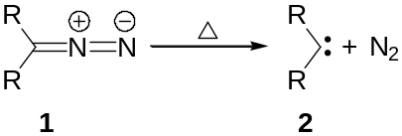
Scheme 1
An extension of the above method uses salts of sulfonyl hydrazones under photolytic or thermal conditions (Scheme 2).⁷
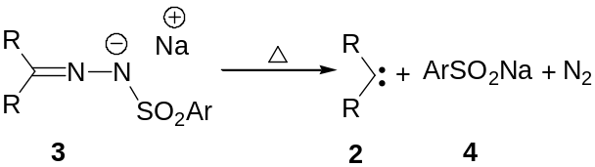
Scheme 2
Although not of any synthetic value, the photolysis of diazirines and epoxides have been shown to generate carbenes (Scheme 3).⁸
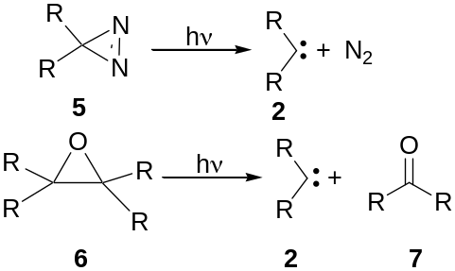
Scheme 3
Organic halides under strong basic conditions or on reaction with organometallic compounds generate carbenes (Scheme 4).⁹

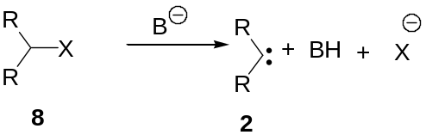
Scheme 4
Another method employed involves the thermolysis of Seyferth reagents (Scheme 5).¹⁰
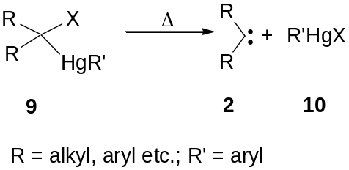
Scheme 5
    - Structure and Reactivity Profiles of Carbenes
Depending on the spin multiplicity, carbenes are divided into singlet and triplet states. Singlet carbenes feature a filled and a vacant orbital, thereby showing ambiphilic character while triplet carbenes have two singly occupied orbitals and are generally regarded as diradicals (Figure 1).
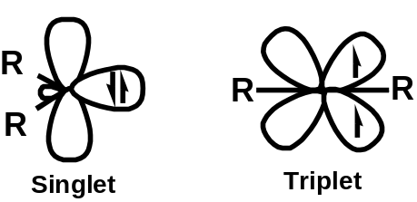
Figure 1
1.1.3a Addition Reactions of Carbenes
Carbene additions to alkenes are the best studied reactions of these intermediates and the addition results in the formation of a cyclopropane derivative. Both singlet and triplet carbenes undergo this reaction and it is possible to find out the spin state of the carbene by observing differences in the stereochemistry of the products formed. A one step mechanism is possible for singlet carbenes thereby affording a single cyclopropane derivative having the same stereochemistry as the starting olefin. In the case of triplet carbenes, due to the intermediacy of diradicals, the cyclopropanes formed will be mixtures of the two possible stereoisomers (Scheme 6).¹¹
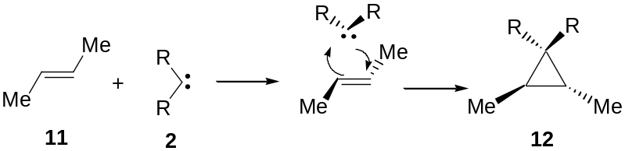
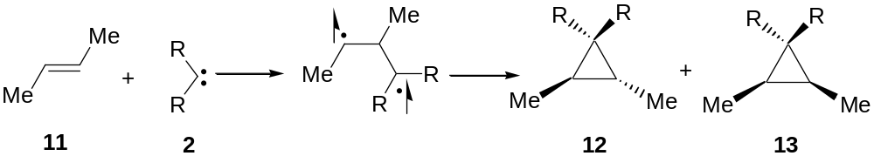
Scheme 6
Several methods have been developed for the synthesis of cyclopropanes from alkenes by the addition of carbenes. Some of these methods are discussed below.
A very effective method for converting an alkene to cyclopropane by transfer of a methylene involves the use of methylene iodide and Zn-Cu couple system, commonly known as Simmons-Smith reagent. The addition is stereo specific and the active species involved is believed to be the iodomethylzinc iodide in equilibrium with (bis) iodomethyl zinc (Scheme 7).¹²
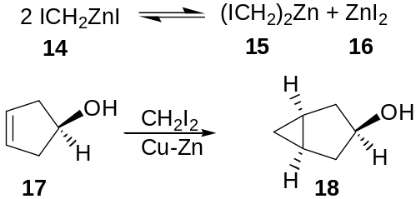
Scheme 7
Seyferth reagents are also found to be effective for cyclopropanation (Scheme 8).¹⁰
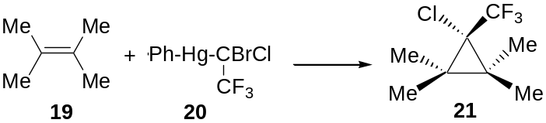
Scheme 8
The α-elimination of organic halides with strong bases in the presence of an alkene is also used as a method for generating cyclopropanes, but this method is seldom used in organic synthesis (Scheme 9).¹³
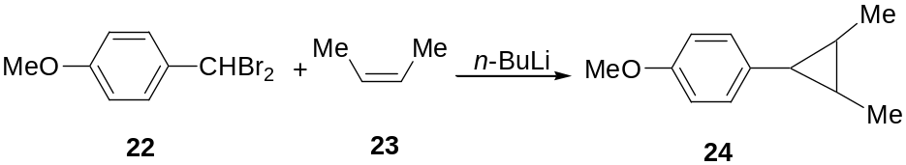
Scheme 9
Intramolecular cyclopropanation reactions are considered to be important in organic synthesis, since this method provides an easy access to highly strained ring compounds (Scheme 10).¹⁴
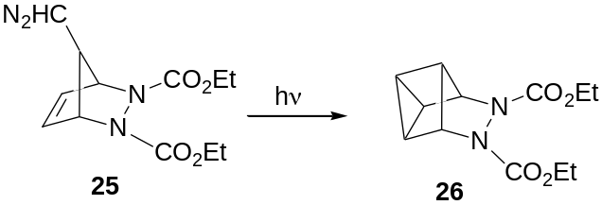
Scheme 10
1.1.3b Insertion Reactions of Carbenes
The most common carbene insertion reactions involve C-H bonds and in these reactions the reactive intermediate interposes itself into an existing bond. Due to the high energy of the intermediates involved, these reactions are found to be very unselective (Scheme 11).¹⁵
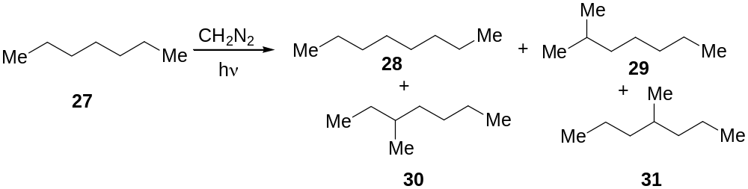
Scheme 11
Intramolecular insertion reactions of carbenes into C-H bonds are synthetically useful for the preparation of strained molecules or cage systems (Scheme 12).¹⁶
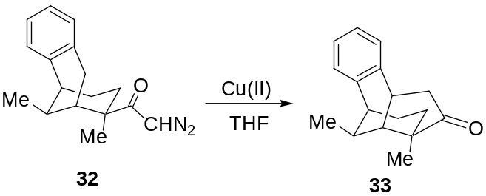
Scheme 12
1.1.3c Rearrangement Reactions of Carbenes
The presence of a vacant p-orbital enables carbenes to undergo facile rearrangement reactions. The most common among them is the migration of hydrogen to generate an alkene (Scheme 13).¹⁷
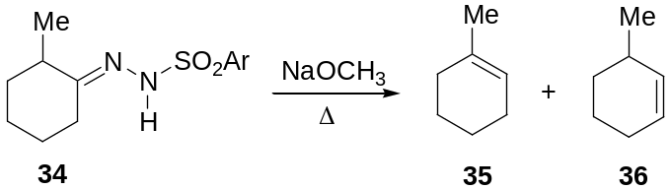
Scheme 13
The best known carbene rearrangement is the Wolff rearrangement of diazo ketones to ketenes (Scheme 14).¹⁸

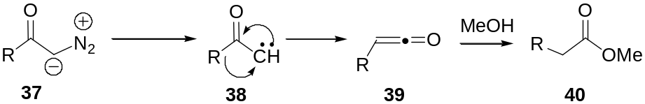
Scheme 14
Another rearrangement reaction involving carbenes is the Skattebøl rearrangement in which a vinyl cyclopropylidene undergoes rearrangement to form a cyclopentadiene (Scheme 15).¹⁹
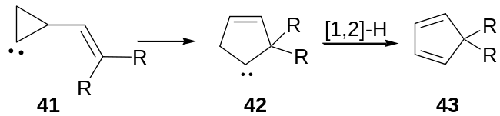
Scheme 15
Similarly aryl carbenes undergo a series of rearrangements when generated in gas phase to afford cycloheptatrienylidene, which on further rearrangement affords a highly strained cycloheptatetraene derivative (Scheme 16).²⁰
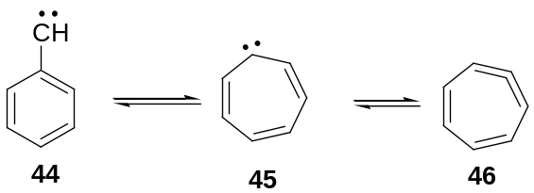
Scheme 16
Cyclopropylidenes, generated under suitable conditions, undergo rearrangement to afford allene derivatives. For instance, the dihalocyclopropane 47 undergoes rearrangement in presence of butyl lithium to afford the allene derivative 48 (Scheme 17).²¹
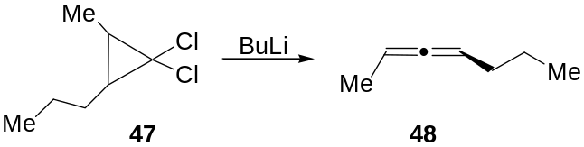
Scheme 17
1.1.3d Nucleophilic Carbenes
Nucleophilic carbenes are characterized by the presence of substituents having donor atoms such as oxygen, nitrogen and sulfur. The nucleophilicity of these species is a direct consequence of the donation of lone pairs of heteroatoms into the formally vacant p-orbital of the carbene carbon. This strongly stabilizes the singlet state and imparts dipolar character (Scheme 18).²²
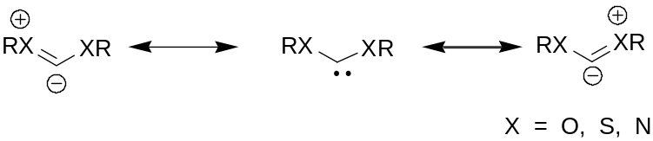
Scheme 18
1.1.3e Generation and Reactivity Patterns of Dialkoxycarbenes
Only a few general methods are available in the literature for the generation of dialkoxycarbenes. The first method developed by Hoffmann in 1971, is based on the thermolysis of norbornadiene ketals. The method is limited to the preparation of only a few alkoxycarbenes and is unsuitable for unsymmetrical carbenes. Moreover the by-products from thermolysis of 49 can interfere with the isolation of products from the reactions of dialkoxycarbenes (Scheme 19).²³
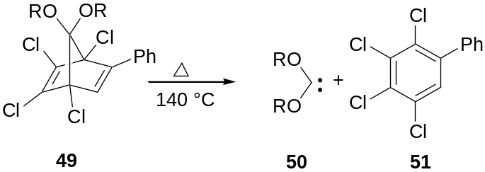
Scheme 19
Later, Moss and coworkers have developed a method based on the photolysis or thermolysis of dialkoxy diazirines. The hazardous nature of these compounds, however, precludes their use in synthetic chemistry (Scheme 20).²⁴
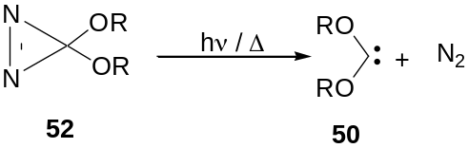
Scheme 20
The identification of Δ³-1,3,4-oxadiazolines as a versatile source of various nucleophilic carbenes by Warkentin can be considered as a milestone in the development of the chemistry of dialkoxycarbenes.²⁵ The oxadiazolines undergo thermolysis at ca 100 °C in solution to afford the corresponding heteroatom substituted carbenes. The initial event in the thermal decomposition of oxadiazolines is a cycloreversion, forming carbonyl ylides of type 54. These dipolar intermediates, with a few exceptions, are not trapped under the reaction conditions. Instead, they undergo successive fragmentation to the corresponding stable singlet carbenes. The ready accessibility and stability of oxadiazolines make them attractive source of dialkoxycarbenes (Scheme 21).²⁶
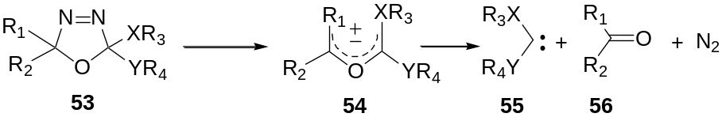
Scheme 21
These carbene precursors are readily available by the oxidation of alkoxycarbonyl hydrazones of acetone with lead tetraacetate (LTA).²⁷ The use of other oxidizing agents like phenyl iodonium acetate has been reported.²⁸ Electrochemical oxidation of ketone hydrazones to oxadiazolines is also known.²⁹ The LTA oxidation affords a mixture of 2-acetoxy-2-methoxy-5,5-dimethyl Δ³-1,3,4-oxadiazoline 58 and an acyclic azo compound 59, which on acid catalyzed displacement reaction with a suitable alcohol affords the required oxadiazoline 60 along with unchanged 59. Selective removal of the latter is achieved by hydrolysis with aqueous base. The advantage of this method is that a single acetoxy substrate 58 can serve as the source of different oxadiazolines (Scheme 22).³⁰
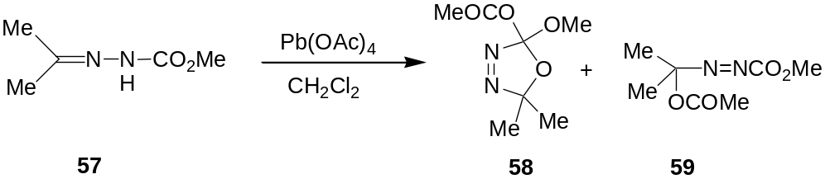
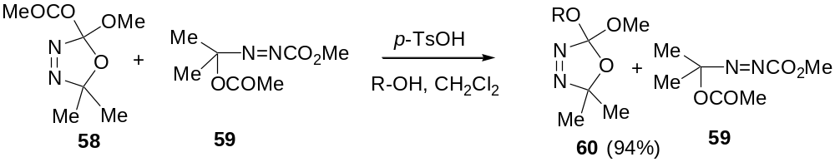Scheme 22
The chemistry of dialkoxycarbenes, especially dimethoxycarbene was the subject of intense investigations by Hoffmann and later by Warkentin, a brief account of which is given in the following passages.
The reactivity of dimethoxycarbene towards electron deficient alkenes and alkynes was studied by Hoffmann. He has demonstrated that dimethoxycarbene, generated by the thermolysis of the acetal 61 undergoes facile addition to diethyl maleate or fumarate to afford the corresponding cyclopropane derivative (Scheme 23).³¹

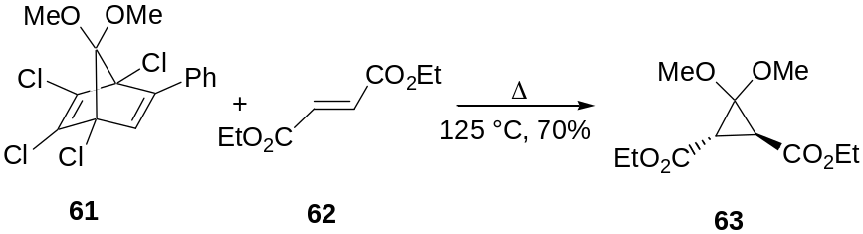
Scheme 23
Similarly, the addition of dimethoxycarbene to an electron deficient alkyne such as dimethyl acetylenedicarboxylate afforded the dihydrofuran derivative 65 in low yield (Scheme 24).³¹
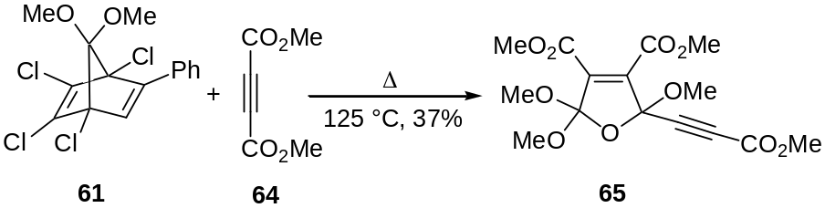
Scheme 24
The addition of dimethoxycarbene to heterocumulenes such as aryl isocyanates and aryl isothiocyanates leads to the formation of substituted hydantoins and thiohydantoins respectively (Scheme 25).³²
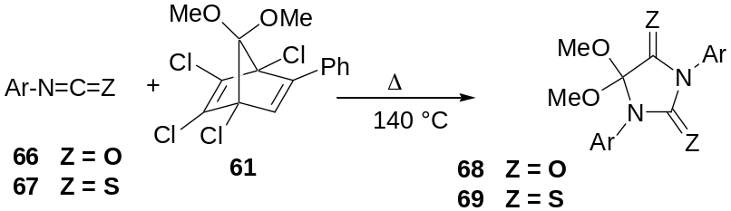
Scheme 25
Dialkoxycarbenes undergo addition reactions with acylimines affording oxazolines (Scheme 26).³³
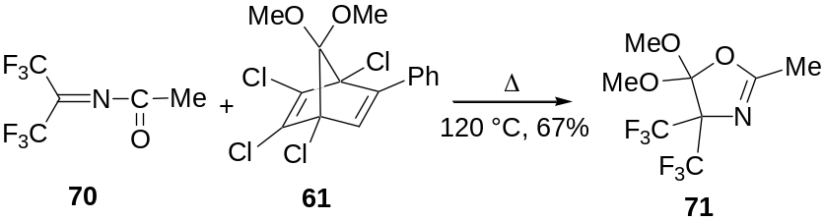
Scheme 26
Styrenes were also found to undergo reaction with dimethoxycarbene to afford cyclopropane derivatives (Scheme 27).³¹
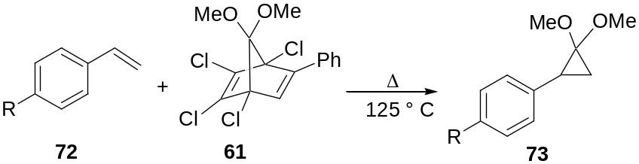
Scheme 27
Under similar reaction conditions, α,β-unsaturated esters also afforded cyclopropane derivatives (Scheme 28).³¹
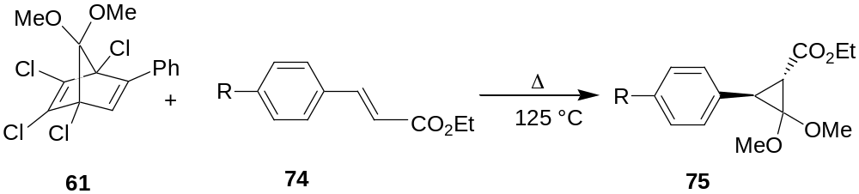
Scheme 28
Dimethoxycarbene on reaction with aryl acetylenes furnished the corresponding 1:2 adduct as shown in Scheme 29.³¹
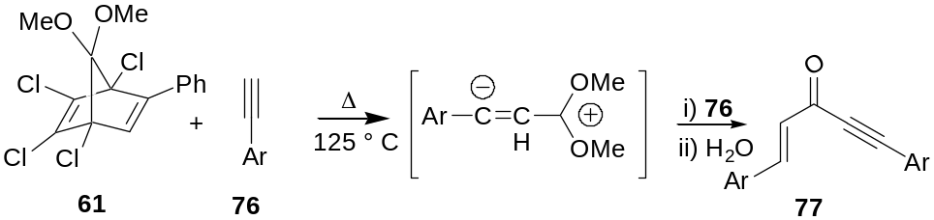
Scheme 29
The addition of dimethoxycarbene to diphenyl ketene afforded the cyclized product 79 in good yield (Scheme 30).³¹
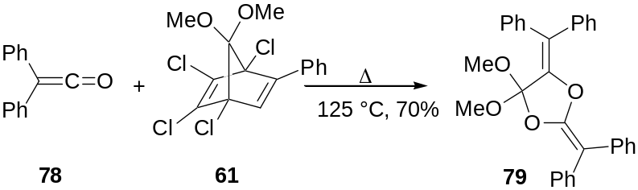
Scheme 30
Warkentin has demonstrated that bisketene generated by the thermolysis of cyclobutenedione 80 undergoes facile addition to dimethoxycarbene to afford cyclopentenedione derivative 82 (Scheme 31).³⁴
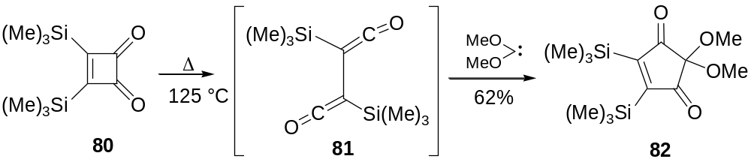
Scheme 31
Recently, Rigby has reported the [4+1] cycloaddition of dimethoxycarbene with vinyl isocyanates leading to the formation of hydroindolone derivatives along with the by-product 68 (Scheme 32).³⁵
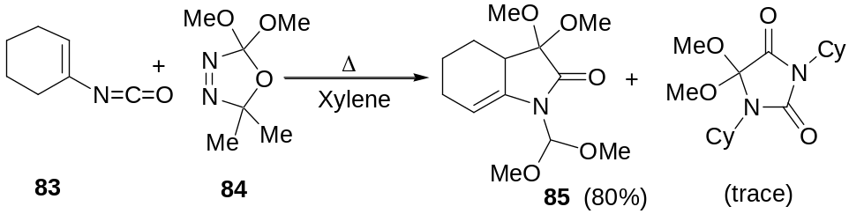
Scheme 32
Hoffmann has reported the reaction of dimethoxycarbene with benzoyl chloride 86 affording methyl benzoyl formate 87 (Scheme 33).³¹
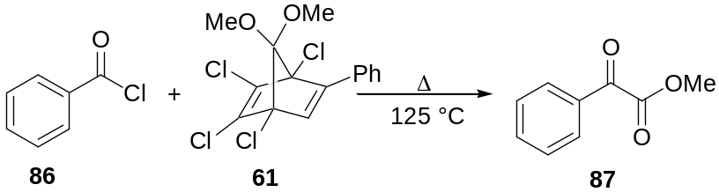
Scheme 33
The reaction of dimethoxycarbene generated by the thermolysis of oxadiazoline 84 with 9-flourenone afforded 9-(dimethoxy methylene)-fluorene oxide 89 and methyl 9-methoxyfluorene-9-carboxylate 90 (Scheme 34).³⁶
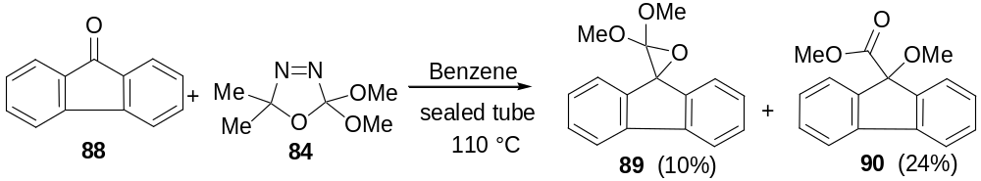Scheme 34
Dimethoxycarbene was found to react with quinonoid compounds such as p-chloranil to afford products resulting from nucleophilic addition of the carbene to the carbonyl group (Scheme 35).³⁷
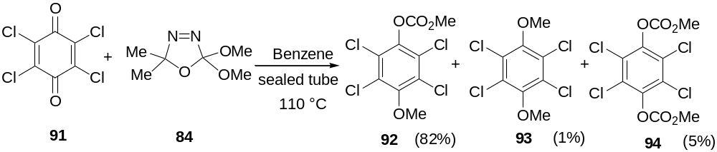Scheme 35
A variety of cyclic anhydrides are reported to react with dialkoxycarbenes leading to the corresponding ring enlarged products (Scheme 36).³⁸
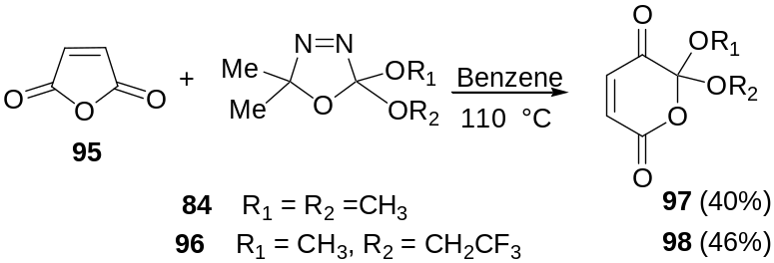
Scheme 36
However, the reaction of methoxy(trimethylsilyl)ethoxycarbene, generated by the thermolysis of oxadiazoline 100 with N-phenyl maleimide, followed a different reaction pathway leading to the formation of product 101 via the migration of the trimethylsilyl group (Scheme 37).³⁹
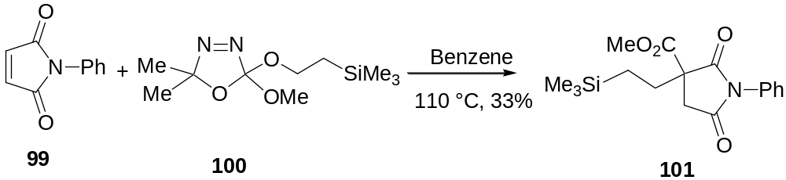
Scheme 37
1,2-diones such as 2,3-butanedione reacts with dimethoxycarbene to form the cyclic compound 103 as shown in Scheme 38.³³
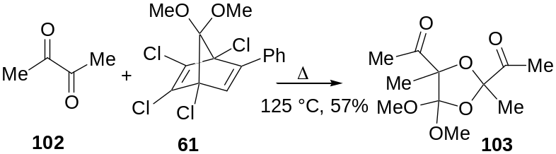
Scheme 38
Dimethoxycarbene generated from the acetal 61 has been intercepted with triazines to afford the corresponding pyrazole via the [4+1] cycloaddition of carbene followed by subsequent cycloreversion (Scheme 39).⁴⁰
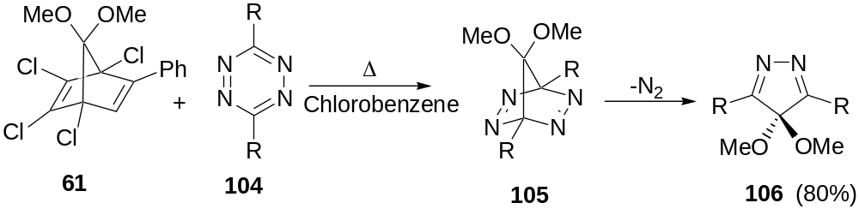
Scheme 39
1,3-dicarbonyl compounds were also found to undergo reaction with dialkoxycarbenes. The reaction of methylacetoacetate with oxadiazoline 84 afforded the corresponding carbene inserted product 108 along with the alkene 109 formed by methanol elimination. Related insertions into alcohols and phenols afford the corresponding orthoformates (Scheme 40).⁴¹
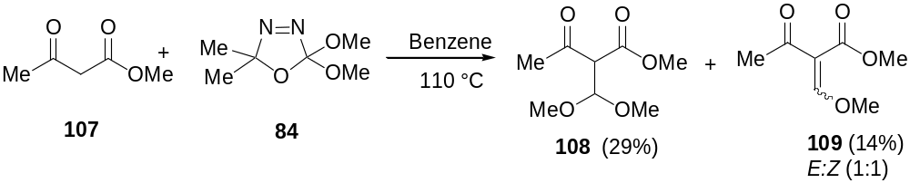Scheme 40
Warkentin and co-workers have shown that the carbene generated by the thermolysis of the oxadiazoline 84 reacts with adamantane thione 110 to afford 1,1-dimethoxy thiirane 111 as a stable solid in excellent yield (Scheme 41).⁴²
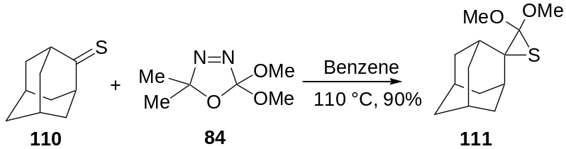
Scheme 41
They have also shown that the thermolysis of 2-methoxy-2-triphenyl siloxy-5,5-dimethyl-∆³-1,3,4-oxadiazoline affords methyl triphenylsilyl formate and methyl triphenylsilyl ether via methoxy triphenyl siloxy carbene (Scheme 42).⁴³
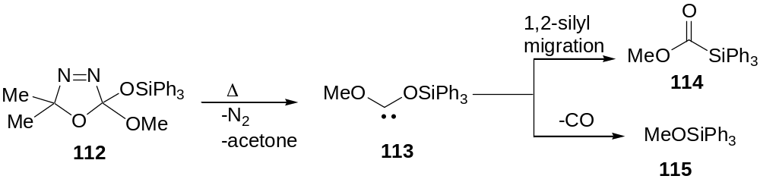
Scheme 42
A probable mechanism for this transformation is depicted in Scheme 43.
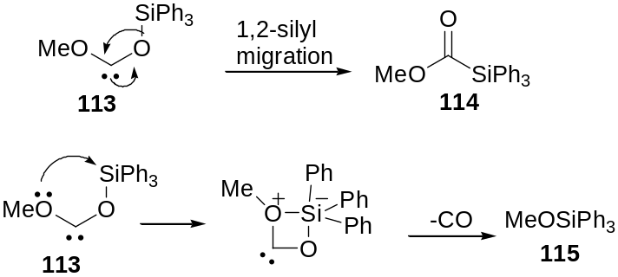
Scheme 43
Similarly the thermolysis of 2-cinnamyloxy-2-methoxy-5,5-dimethyl-∆³-1,3,4-oxadiazoline afforded the products 120 and 121 in the ratio 2:1. The carbene generated under the reaction conditions undergoes a “β-scission” to afford radical pairs, which on subsequent rearrangement and recombination afforded the corresponding products. The formation of free radical intermediates in this reaction was confirmed by interception using radical scavengers such as TEMPO (Scheme 44).⁴⁴
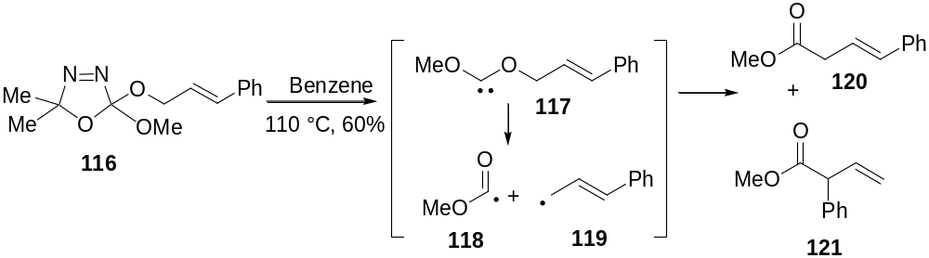Scheme 44
In a mechanistically intriguing reaction, the thermolysis of bis oxadiazoline 122 in presence of DMAD afforded the benzofused tricyclic compound 123 in moderate yield (Scheme 45).⁴⁵
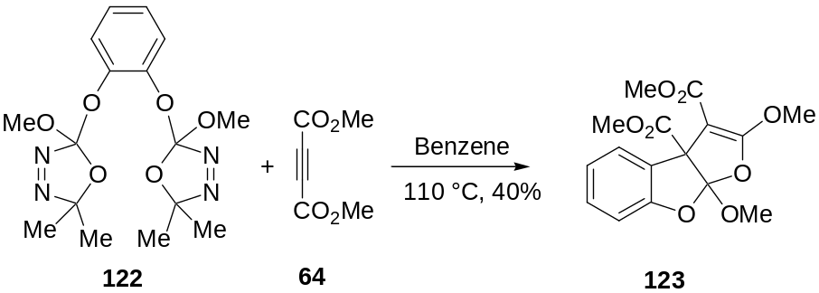
Scheme 45
Similarly, it has been reported that on thermolysis, oxadiazolines substituted with alkyne functionalities undergo an interesting rearrangement to furnish the tricyclic product 126 in good yield (Scheme 46).⁴⁶
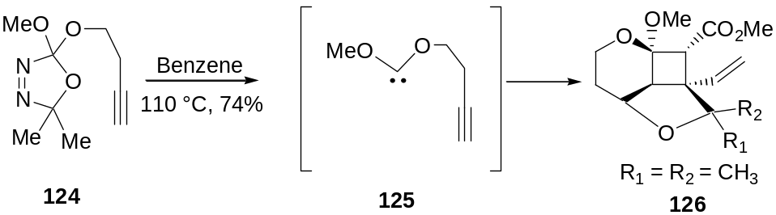
Scheme 46
The reaction of dimethoxycarbene with C₆₀ fullerene was reported to afford the dimethoxy methanofullerene derivative (Scheme 47).⁴⁷
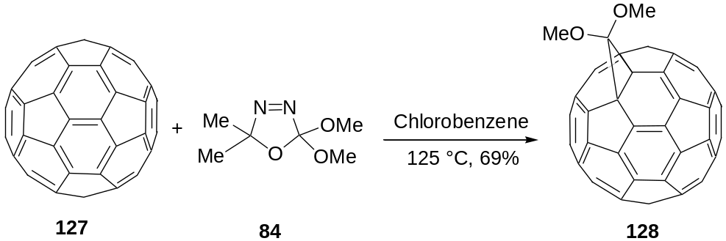
Scheme 47
The thermolysis of methoxy(2-trimethylsilyl)ethoxycarbene in presence of C₆₀, however, did not afford the dialkoxy methanofullerene derivative; instead it afforded the products 129 and 130 via rearrangement reactions (Scheme 48).⁴⁷
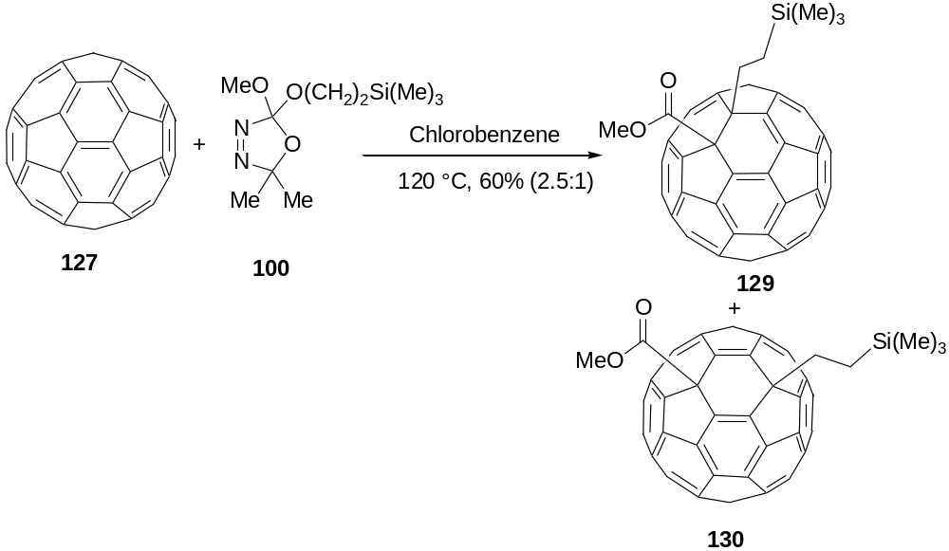
Scheme 48
1.1.3f Generation and Reactivity Patterns of Alkoxyamino carbenes
Warkentin has demonstrated that alkoxy aminocarbenes can be generated by the thermolysis of alkoxyamino oxadiazolines of the type 136, the synthesis of which is outlined in Scheme 49.⁴⁸
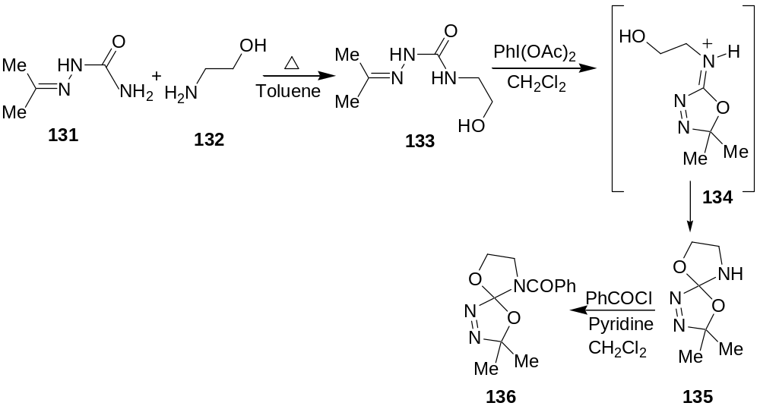Scheme 49
The reaction of these carbenes with activated triple bonds has been reported (Scheme 50).⁴⁸
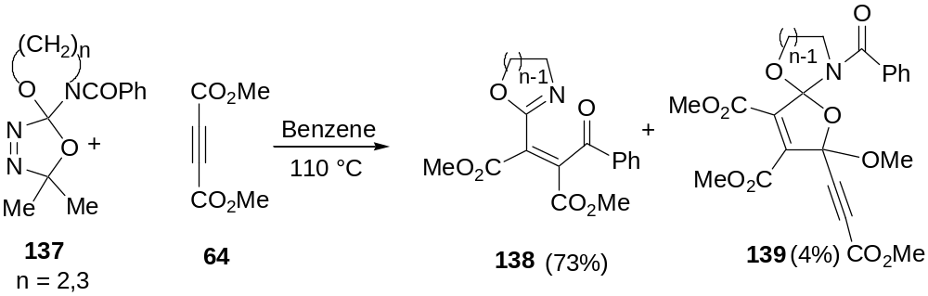
Scheme 50
Recently Rigby and coworkers have investigated the [4+1] cycloaddition of alkoxy amino carbenes with vinyl isocyanates and this strategy has been applied for the synthesis of enantiopure hydroisatin (Scheme 51).⁴⁹
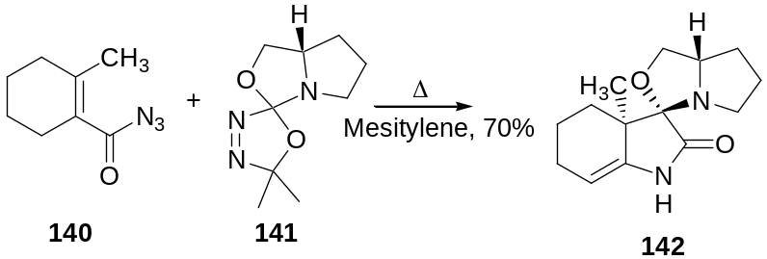
Scheme 51
1.1.3g Generation and Reactivity Pattern of Alkoxy Alkylthiocarbenes
The alkoxy alkylthiocarbenes can be conveniently prepared from the precursor 143, which in turn was obtained from the acetoxy oxadiazoline 58 by acid catalyzed exchange reaction with the corresponding thiol (Scheme 52).⁵⁰
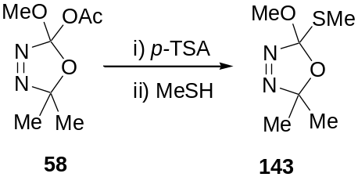
Scheme 52
The alkoxy alkylthio oxadiazolines undergo thermolysis at 60-80 °C in solution to generate alkoxy thiocarbenes and they have been intercepted with suitable electrophiles such as DMAD, phenyl isocyanate, ethyl crotonate etc. A typical example involving phenyl isocyanate is shown in Scheme 53.⁵⁰
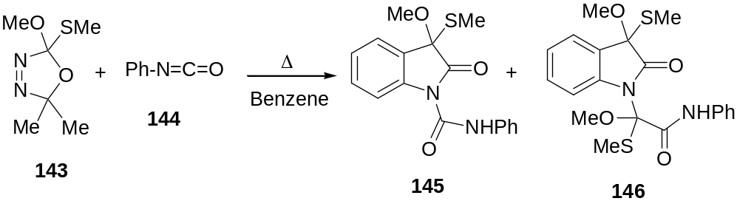
Scheme 53
1.1.3h Generation and Reactivity Patterns of Dithiocarbenes
Dithiocarbenes are generated by the thermolysis of the corresponding dithio oxadiazolines, which in turn are prepared by a slight modification of the Warkentin protocol as depicted in Scheme 54.⁵¹
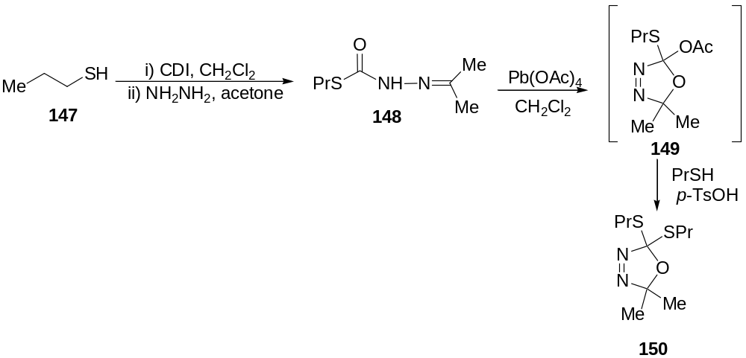Scheme 54
The thermolysis of the dithio oxadiazoline 150 in presence of acyl azide afforded the corresponding hydroindolone derivative 152 in good yield (Scheme 55).⁵²
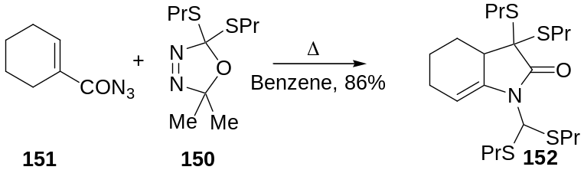
Scheme 55
The use of excess of oxadiazoline, however, afforded the hydropyridone derivative 153 (Scheme 56).⁵²
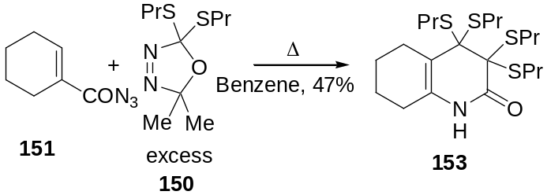
Scheme 56
The bis (alkylthio)carbenes undergo a [4+1] cycloaddition with aryl isocyanates to furnish isatin derivatives (Scheme 57).⁵³
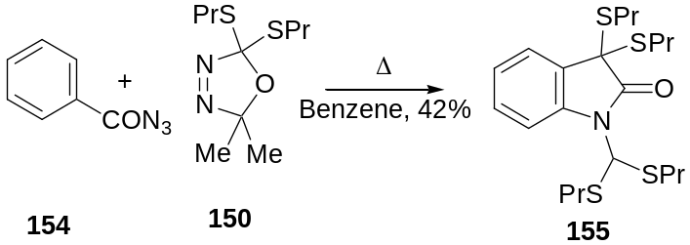
Scheme 57
Rigby and coworkers have applied the strategy of [4+1] cycloaddition of dithiocarbenes with functionalized vinyl isocyanates in the total synthesis of (±) mesembrine 158 (Scheme 58).⁵⁴
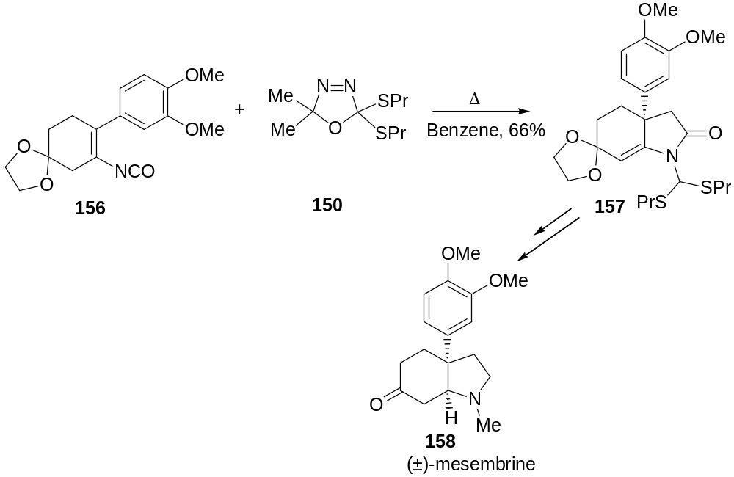
Scheme 58
1.1.3i Generation and Reactivity Pattern of β-Lactam-4-ylidenes
Warkentin has shown that β-lactam ylidenes can be generated by the thermolysis of spiro fused β-lactam oxadiazolines of the type 161. These compounds are prepared by the [2+2] cycloaddition of an imino oxadiazoline 160 with a ketene generated in situ (Scheme 59).⁵⁵
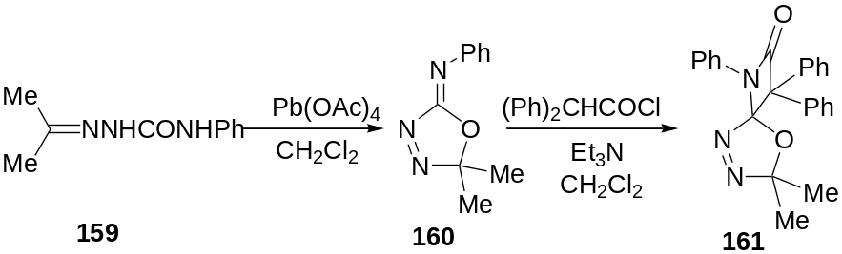
Scheme 59
The β-lactam ylidene 162 generated by the thermolysis of 161 is reported to react with activated and unactivated alkenes and alkynes affording the cyclopropane derivatives. A typical example involving DMAD is shown below (Scheme 60).⁵⁶
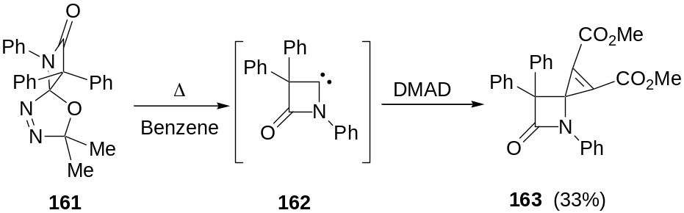
Scheme 60
1.1.3j Generation and Reactivity Patterns of Diaminocarbenes
An introduction to the generation and reactivity profiles of diaminocarbenes is presented in Chapter 4 (see section 4.1 in Chapter 4).
1.2 Multicomponent Reactions
Conventional preparative procedures in organic synthesis involve stepwise formation of individual bonds and are often tedious and involve many synthetic steps. Reactions in which more than two starting materials react to form a product in such a way that the majority of the atoms of the starting materials can be found in the product are called multicomponent reactions (MCRs).⁵⁷ The reagents employed may be different molecules or they may be different functional groups of the same reagent. These reactions can either be carried out in solution or on a solid support.
Multicomponent reactions are further classified in to three basic types as shown in Table 1.
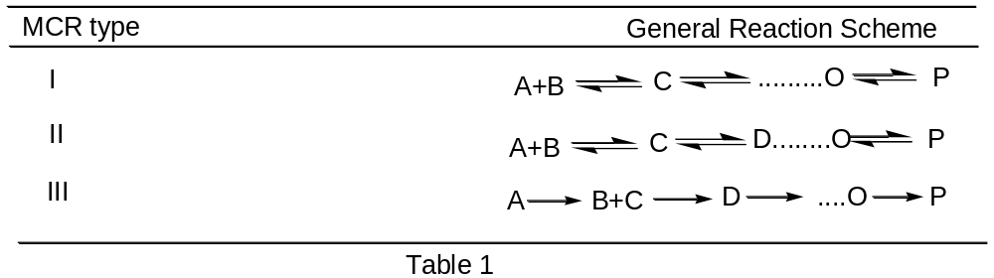
In the type I MCRs, the starting materials, intermediates and products are in a mobile equilibrium. MCRs whose elementary reactions involve either equilibria or partial irreversible reactions and whose last step is irreversible belong to type II. Reactions of this type are preparatively advantageous as the total equilibrium is shifted to the side of the products by the last irreversible step. Type III MCRs comprise sequences of elementary reactions and they seldom occur in preparative chemistry. A number of advantages make MCRs attractive both in organic and combinatorial synthesis viz., simple procedures, facile execution, atom economy, convergence and ecofriendliness. MCRs offer great promise in the synthesis of heterocycles and are especially remarkable for their ease of execution and come closer to ideal synthesis defined by Wender.⁵⁸
The history of MCRs can be traced to the work of Laurent and Gerhardt when they prepared “benzoylazotide” from bitter almond oil and ammonia. In this reaction, benzaldehyde undergoes a Strecker reaction with hydrocyanic acid and ammonia to give aminobenzyl cyanide 165 whose Schiff base with benzaldehyde has been isolated as the so called “benzoylazotide” (Scheme 61).⁵⁹
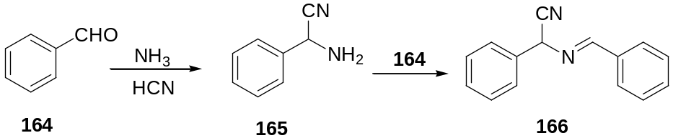
Scheme 61
The Strecker amino acid synthesis, reported in the 1850s is considered as another important multicomponent reaction. This involves the three component condensation of ammonia, an aldehyde and hydrogen cyanide to afford an α-amino nitrile which on subsequent hydrolysis furnishes the α-amino acid derivative. Safer, milder and more selective reaction conditions have been developed and the reaction has been extended to include primary and secondary amines (Scheme 62).⁶⁰
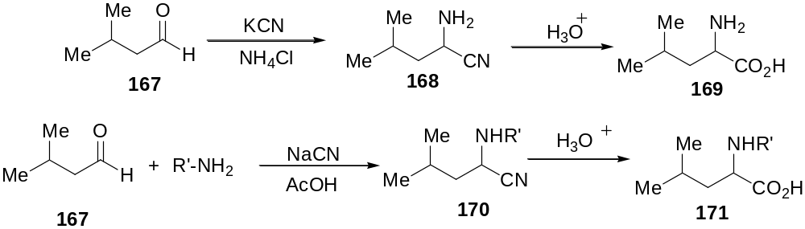Scheme 62
The synthesis of 1,4-dihydropyridines of the type 174 from ammonia, aldehyde and acetoacetic ester has been reported a century ago by Hantzsch and coworkers (Scheme 63).⁶¹ Recently, this methodology has been applied to the synthesis of Nifedipin®, an important drug used in cardiovascular therapy.
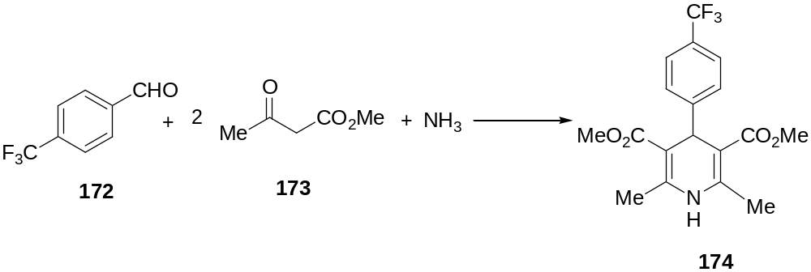
Scheme 63
The Biginelli condensation of an aldehyde, β-keto ester and urea leading to the synthesis of dihydropyrimidines is considered as another important multicomponent reaction. The dihydropyrimidine derivatives are compounds with important biological properties and they play a prominent role as calcium antagonistic reagents (Scheme 64).⁶²
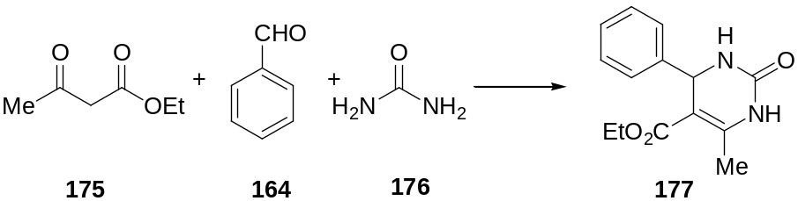
Scheme 64
A commonly used and important multicomponent reaction is the Mannich reaction, which involves a one pot synthesis of amino methylated carbonyl compounds from formaldehyde, secondary amine and ketones (Scheme 65). This reaction has proved to be extremely valuable in the total synthesis of several natural products.⁶³
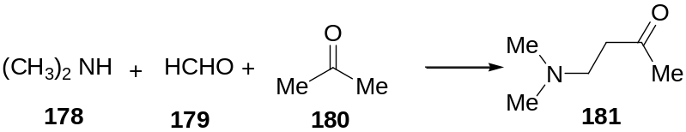
Scheme 65
Robinson’s Tropinone synthesis from succinic aldehyde, methylamine and dimethyl acetonedicarboxylate provides a spectacular example of the application of MCRs in natural product synthesis (Scheme 66).⁶⁴
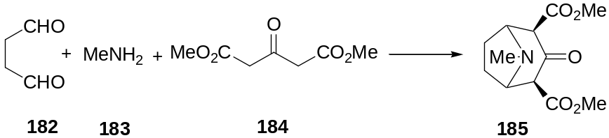
Scheme 66
Among the large class of multicomponent reactions reported so far, the major and the most successful ones are isocyanide based multicomponent reactions (IMCRs). The most important IMCRs are the Passerini 3-component reaction (P-3CR) and the Ugi 4-component reaction (U-4CR), a brief account of which is given in the following sections.
1.2.1 Passerini Reaction
The formation of α-acyloxy carboxamides 188 by the three component reaction between isocyanides, carboxylic acids and carbonyl compounds is known as the Passerini reaction, an example of which is given in the following scheme (Scheme 67).⁶⁵
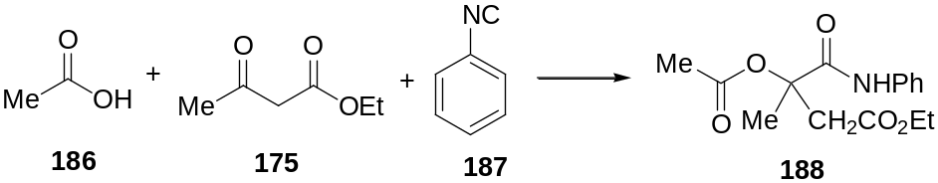
Scheme 67
The reaction has been applied to the total synthesis of many natural products; a typical example involving the total synthesis of an alkaloid (±)-hydrastine 192 is outlined below (Scheme 68).⁶⁶
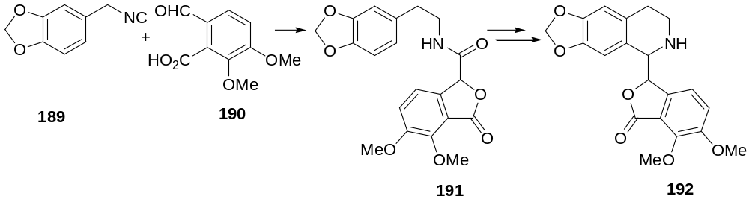Scheme 68
The Passerini reaction is accelerated in aprotic solvents, indicating a non-ionic mechanism. A mechanistic rationale for this reaction is shown in Scheme 69.
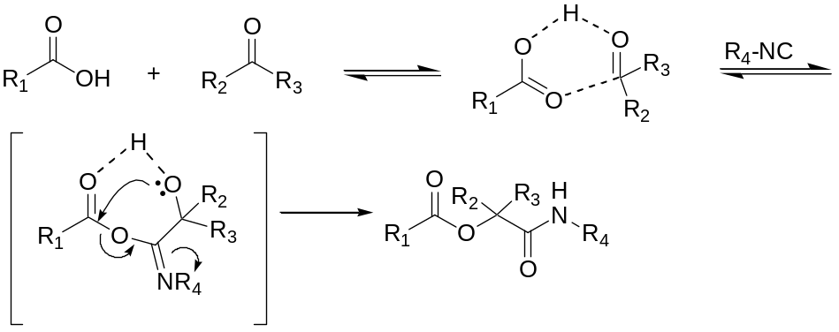
Scheme 69
A variant of this reaction employing an α-chloroketone 195, isocyanide 194 and carboxylic acid 193 has been applied to the synthesis of azetidinones (Scheme 70).⁶⁷
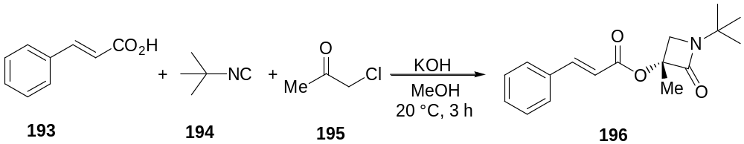
Scheme 70
1.2.2 Ugi Reaction
In 1959, Ugi and coworkers reported the most important IMCR.⁶⁸ The characteristic feature of the Ugi reaction is the α-addition of an iminium ion and the conjugate base of a carboxylic acid to an isocyanide, followed by spontaneous rearrangement of the α-adduct to yield an α-amino carboxamide derivative. Carbonyl compounds and amines, or their condensation products, serve as precursors to the iminium ion (Scheme 71).
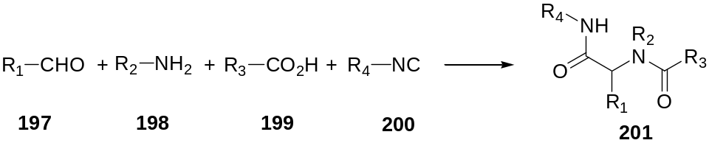
Scheme 71
The mechanism for this reaction is shown below (Scheme 72).
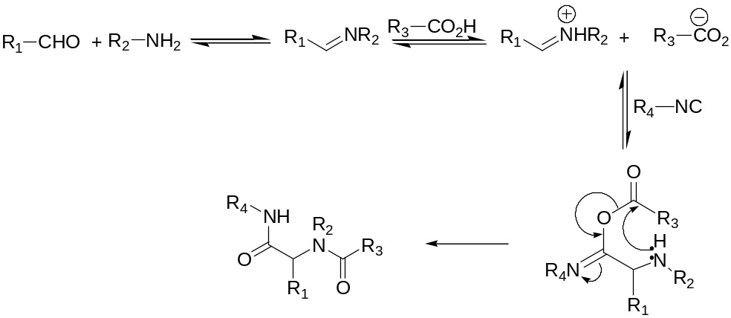
Scheme 72
Any known type of C-isocyanide can be used as the isocyanide component and the only restriction for the acid component is that it must be able to rearrange irreversibly from the intermediate α-adduct of the isocyanide to deliver a stable product. The Ugi 4CR has been widely applied for the synthesis of β-lactams and β-lactam containing antibiotics (Scheme 73).⁶⁹
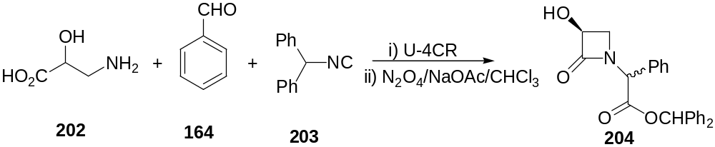
Scheme 73
Work in our laboratory has revealed that the 1:1 intermediate formed by the addition of isocyanides to DMAD could be intercepted by a range of electrophiles thereby constituting novel multicomponent reactions. Details of this work are presented in Chapter 2 (see section 2.2 in Chapter 2).
1.3 Definition of the Problem
It is evident from the literature survey presented above that the chemistry of nucleophilic carbenes especially dialkoxy, alkoxyamino, diamino, alkoxythio, and dithiocarbenes has been investigated to a lesser extent. In particular, the potential use of these carbenes in multicomponent reactions has not been studied so far. Against this literature background and in view of our sustained interest in devising novel multicomponent reactions employing nucleophilic species, we undertook a detailed investigation of the formation of zwitterions by the reaction of nucleophilic carbenes with activated acetylenes and the interception of these zwitterions with various electrophiles in one pot. The carbenes selected for our study include dimethoxycarbene and N-heterocyclic carbenes such as 1,3-dimesityl-imidazolin-2-ylidene and 1,3-dimesityl-imidazol-2-ylidene. The activated alkyne of choice was dimethyl acetylenedicarboxylate (DMAD). The electrophiles employed in the study are various carbonyl compounds such as aldehydes, ketones, and α,β-unsaturated carbonyl compounds.
In the initial phase of our study we have undertaken a systematic investigation of the reactivity pattern of the 1:1 intermediate formed by the addition of dimethoxycarbene and DMAD with various carbonyl compounds. To make the study more comprehensive, we have carried out some investigations on the chemistry of the adducts formed in the aforementioned multicomponent reactions. These results comprise the subject matter of second and third chapters.
The last phase of our study was focused on the reaction of N-heterocyclic carbenes towards DMAD and aromatic aldehydes and the results constitute the subject matter of the fourth chapter.
1.4 References:
- a) Herrmann, W. A. Angew. Chem., Int. Ed. Engl. 2002, 41, 1290. b) Herrmann, W. A.; Köcher, C. Angew. Chem., Int. Ed. Engl. 1997, 36, 2162.
- a) Kirmse, W. Carbene Chemistry, 2nd ed.; Ed.; Academic Press, New York; 1971. b) Jones, M.; Moss, R. A. Carbenes; Ed.; John Wiley and Sons: New York, 1973 and 1975; Vols. I and II. c) Hine, J. Divalent Carbon; Ed.; Ronald Press: New York; 1964. d) Brinker, U. H. Advances in Carbene Chemistry; Ed.; Jai Press: Stamford, 1998; Vol.2.
- Geuther, A. Liebigs Ann. Chem. 1862, 123, 121.
- Staudinger, H.; Kupfer, O. Ber. Dtsch. Chem. Ges. 1912, 45, 501.
- Doering, W. v. E.; Hoffmann, A. K. J. Am. Chem. Soc. 1954, 76, 6162.
- Baron, W. J.; De Camp, M. R.; Hendrick, M. E.; Jones, M. Jr.; Levin, R. H.; Sohn, M. B. in Carbenes; Ed.; John Wiley and Sons, New York, 1973, p.1.
- Bamford, W. R.; Stevens, T. S. J. Chem. Soc. 1952, 4735.
- a) Frey, H. M. Adv. Photochem. 1966, 4, 225. b) Smith, R. A. G.; Knowles, J. R. J. Chem. Soc., Perkin Trans. 2 1975, 686. c) Griffin, G. W.; Bertoniere, N. R.; Jones, M. Jr.; Moss, R. A. in Carbenes; Ed.; John Wiley and Sons: New York, 1973, p. 318.
- Miller, W. T. Jr.; Kim, C. S. Y. J. Am. Chem. Soc. 1959, 81, 5008.
- Seyferth, D. Acc. Chem. Res. 1972, 5, 65.
- a) Hoffmann, R. J. Am. Chem. Soc. 1968, 90, 1475. b) Goddard, W. A. III. J. Am. Chem. Soc. 1972, 94, 793. c) Zurawski, B.; Kutzelnigg, W. J. Am. Chem. Soc. 1978, 100, 2654.
- a) Simmons, H. E.; Smith, R. D. J. Am. Chem. Soc. 1958, 80, 5323. b) ibid 1959, 81, 4256. c) Simmons, H. E.; Cairns, T. L.; Vladuchick, S. A.; Hoiness, C. M. Org. React. 1973, 20, 1.
- Closs, G. L.; Moss, R. A. J. Am. Chem. Soc. 1964, 86, 4042.
- a) Trost, B. M.; Cory, R. M.; Scudder, P. H.; Neubold, H, B. J. Am. Chem. Soc. 1973, 95, 7813. b) Baldwin, J. E.; Smith, R. A. J. Am. Chem. Soc. 1967, 89, 1886.
- Richardson, D. B.; Simmons, M. C.; Dvoretzky, I. J. Am. Chem. Soc. 1961, 83, 1934.
- Ghatak, U. R.; Chakrabarty, S. J. Am. Chem. Soc. 1972, 94, 4756.
- Wilt, J. W.; Wagner, W. J. J. Org. Chem. 1964, 29, 2788.
- Meier, H.; Zeller, K. -P. Angew. Chem., Int. Ed. Engl. 1975, 14, 32.
- Jones, E. R. H.; Skattebøl, L.; Whiting, M. C. J. Chem. Soc. 1956, 4765.
- a) Joines, R. C.; Turner, A. B.; Jones, W. M. J. Am. Chem. Soc. 1969, 91, 7754. b) Baron, W. J.; Jones, M. Jr.; Gaspar, P. P. J. Am. Chem. Soc. 1970, 92, 4739.
- Moore, W. R.; Ward, H. R. J. Org. Chem. 1960, 25, 2073.
- a) Moss, R. A. Acc. Chem. Res. 1989, 22, 15. b) Rondan, N. G.; Houk, K. N.; Moss, R. A. J. Am. Chem. Soc. 1980, 102, 1770. c) Moreno, M.; Lluch, J. M.; Oliva, A.; Bertran, J. J. Chem. Soc., Perkin Trans. 2 1986, 183. d) Moss, R. A.; Young, C. M.; Perez, L. A.; Krogh-Jespersen, K. J. Am. Chem. Soc. 1981, 103, 2413. e) Pole, D. L.; Sharma, P. K.; Warkentin, J. Can. J. Chem. 1996, 74, 1335.
- Hoffmann, R. W. Angew. Chem., Int. Ed. Engl. 1971, 10, 529.
- Moss, R. A.; Wlostowki, M.; Terpinski, J.; Kmeick-Lawrynowicz, G.; Krogh-Jespersen, K. J. Am. Chem. Soc. 1987, 109, 3811.
- Warkentin, J. J. Chem. Soc., Perkin Trans. 1 2000, 2161 and references cited therein.
- a) Couture, P.; El-Saidi, M.; Warkentin, J. Can. J. Chem. 1997, 75, 326. b) Sharma, P. K.; Warkentin, J. Tetrahedron Lett. 1995, 36, 7591.
- Warkentin, J. Synthesis 1970, 279.
- Yang, R. -Y.; Dai, L. -x. J. Org. Chem. 1993, 58, 3381.
- Chiba, T.; Okimoto, M. J. Org. Chem. 1992, 57, 1375.
- Kassam, K.; Pole, D. L.; El-Saidi, M.; Warkentin, J. J. Am. Chem. Soc. 1994, 116, 1161.
- Hoffmann, R. W.; Lilienblum, W.; Dittrich, B. Chem. Ber. 1974, 107, 3395.
- Hoffmann, R. W.; Steinbach, K.; Dittrich, B. Chem. Ber. 1973, 106, 2174.
- Hoffmann, R. W.; Steinbach, K.; Lilienblum, W. Chem. Ber. 1976, 109, 1759.
- Colomvakos, J. D.; Egle, I.; Ma. J.; Pole, D. L.; Tidwell, T. T.; Warkentin, J. J. Org. Chem. 1996, 61, 9522.
- Rigby, J. H.; Cavezza, A.; Ahmed, G. J. Am. Chem. Soc. 1996, 118, 12848.
- Pole, D. L.; Warkentin, J. J. Org. Chem. 1997, 62, 4065.
- Dunn, J. A.; Pezacki, J. P.; McGlinchey, M. J.; Warkentin, J. J. Org. Chem. 1999, 64, 4344.
- Pole, D. L.; Warkentin, J. Liebigs Ann. 1995, 1907.
- Sharma, P. K.; Dawid, M.; Warkentin, J. J. Org. Chem. 2001, 66, 7496.
- Gerninghaus, C.; Kümmell, A.; Seitz, G. Chem. Ber. 1993, 126, 733.
- a) Couture, P.; Pole, D. L.; Warkentin, J. J. Chem. Soc., Perkin Trans. 2 1997, 1565. b) Moss, R. A.; Wlostowski, M.; Shen, S.; Krogh-Jespersen, K.; Matro, A. J. Am. Chem. Soc. 1988, 110, 4443.
- Dawid, M.; Mlostoñ, G.; Warkentin, J. Org. Lett. 2001, 3, 2455.
- Pezacki, J. P.; Loncke, P. G.; Ross, P. J.; Warkentin, J.; Gadosy, T. A. Org. Lett. 2000, 2, 2733.
- Venneri, P. C.; Warkentin, J. j. Am. Chem. Soc. 1998, 120, 11182.
- Lu, X.; Warkentin, J. Tetrahedron Lett. 1999, 40, 1483.
- Kassam, K.; warkentin, J. J. Org. Chem. 1994, 59, 5071.
- a) Win, W. W.; Kao, M.; Eiermann, M.; McNamara, J. J.; Wudl, F. J. Org. Chem. 1994, 59, 5871. b) González, R.; Wudl, F.; Pole, D. L.; Sharma, P. K.; Warkentin, J. J. Org. Chem. 1996, 61, 5837.
- Couture, P.; Terlow, J. K.; Warkentin, J. J. Am. Chem. Soc. 1996, 118, 4214.
- Rigby, J. H.; Cavezza, A.; Heeg, M. J. tetrahedron Lett. 1999, 40, 2473.
- Er, H. -T.; Pole, D. L.; Warkentin, J. can. J. Chem. 1996, 74, 1480.
- Rigby, j. H.; Laurent, S.; Dong, W.; Danca, D. M. Tetrahedron 2000, 56, 10101.
- Rigby, J. H.; Laurent, S. J. org. Chem. 1999, 64, 1766.
- Rigby, J. H.; Danca, D. M. Tetrahedron Lett. 1999, 40, 6891.
- Rigby, J. H.; Dong, W. Org. Lett. 2000, 2, 1673.
- Zoghbi, M.; Warkentin, J. J. Org. Chem. 1991, 56, 3214.
- Zoghbi, M.; Horne, S. E.; Warkentin, J. J. Org. Chem. 1994, 59, 4090.
- Domling, A.; Ugi, I. Angew Chem., Int. Ed. Engl. 2000, 39, 3168.
- Wender, P. A.; Handy, P. A.; Wright, D. L. Chem. Ind. 1997, 765.
- a) Laurent, A.; Gerhardt, C. F. Ann. Chem. et Physique 1838, 66, 181. b) Laurent, A.; Gerhardt, C. F. Liebigs Ann. Chem. 1838, 28, 265.
- Strecker, A. Liebigs Ann. Chem. 1850, 75, 27.
- Hantzsch, A. Justus Liebigs Ann. Chem. 1882, 215, 1.
- Biginelli, P. Ber. Dtsch. Chem. Ges. 1891, 24, 1317.
- Mannich, C.; Krösche, W. Arch. Pharm. 1912, 250, 647.
- Robinson, R. J. Chem. Soc. 1917, 111, 876.
- Passerini, M. Gazz. Chim. Ital. 1921, 51, 126.
- Flack, J. R.; Manna, R. S. Tetrahedron Lett. 1981, 22, 619.
- Bossio, R.; Marcos, C. F.; Marcaccini, S.; Pepino, R. Tetrahedron Lett. 1997, 38, 2519.
- Ugi, I.; Meyr, R.; Fetzer, U.; Steinbrückner, C. Angew. Chem. 1959, 71, 386.
- Isenring, H. P.; Hofheinz, W. Synthesis 1981, 385.

